**SECURITY SERVICE MANAGEMENT SYSTEM FOR RALL**

**Sri Lanka Institute of Information Technology**



**IT2080 – Information Technology Project**

**System Design Activity**

**Group ID: ITP24R_B1_W22**

**Team Members**

|  |  |  |
| --- | --- | --- |
|  | **Name with Initials** | **Student ID** |
| **01.** | Fernando K. K. C | IT22325228 |
| **02.** | Sadisha R. M. M | IT22907998 |
| **03.** | Dissanayaka D. M. S. M | IT20145552 |
| **04.** | Randiw E. Y | IT22257086 |
| **05.** | Jayodhya J. D. H | IT22293480 |
| **06.** | Medawatte W. W. M. T. N. B | IT22127082 |
| **07.** | Kusumsiri P. A. S. S | IT22132628 |
| **08.** | Ranasinghe R. A. R. V. C | IT22197146 |

**Date:** 31**.**08.2024

**Contents**

Major Components 5

1. User Management 5

2. Training Management 5

3. Client Management 5

4. Booking Management 5

5. Payment Management 6

6. Operation Management 6

7. Inventory Management 6

8. Employee Management 6

Data Model 7

Non-Functional Requirements 10

Third-Party Components 13

Graphical User Interface (GUI) 14

IT22325228 – Fernando K. K. C | User Management 14

IT22907998 – Sadisha R. M. M | Training Management 25

IT20145552 – Dissanayaka D. M. S. M | Client Management 31

IT22257086 – Randiw. E. Y | Booking Management 34

IT22293480 – Jayodhya J. D. H | Payment Management 35

IT22127082 – Medawatte W. W. M. T. N. B | Operation Management 37

IT22132628 – Kusumsiri P. A. S. S | Inventory Management 38

IT22197146 – Ranasinghe R. A. R. V. C | Leave Management 43

UML Diagrams 45

IT22325228 – Fernando K. K. C | User Management 45

Class Diagram 45

Sequence Diagram 46

Activity Diagram 47

ER Diagram 48

IT22907998 – Sadisha R. M. M | Training Management 49

Class Diagram 49

Sequence Diagram 50

Activity Diagram 51

ER Diagram 52

IT20145552 – Dissanayaka D. M. S. M | Client Management 53

Class Diagram 53

Sequence Diagram 54

Activity Diagram 55

ER Diagram 56

IT22257086 – Randiw. E. Y | Booking Management 57

Class Diagram 57

Sequence Diagram 58

Activity Diagram 59

ER Diagram 60

IT22293480 – Jayodhya J. D. H | Payment Management 61

Class Diagram 61

Sequence Diagram 62

Activity Diagram 63

ER Diagram 64

IT22127082 – Medawatte W. W. M. T. N. B | Operation Management 65

Class Diagram 65

Sequence Diagram 66

Activity Diagram 67

ER Diagram 68

IT22132628 – Kusumsiri P. A. S. S | Inventory Management 69

Class Diagram 69

Sequence Diagram 70

Activity Diagram 71

ER Diagram 72

IT22197146 – Ranasinghe R. A. R. V. C | Leave Management 73

Class Diagram 73

Sequence Diagram 74

Activity Diagram 75

ER Diagram 76

System Diagram 77

Relational Schema 78

IT22325228 – Fernando K. K. C | User Management 78

IT22907998 – Sadisha R. M. M | Training Management 79

IT20145552 – Dissanayaka D. M. S. M | Client Management 79

IT22257086 – Randiw. E. Y | Booking Management 80

IT22293480 – Jayodhya J. D. H | Payment Management 80

IT22127082 – Medawatte W. W. M. T. N. B | Operation Management 81

IT22132628 – Kusumsiri P. A. S. S | Inventory Management 81

IT22197146 – Ranasinghe R. A. R. V. C | Leave Management 82

# Major Components

### 1. User Management

**Components:**

* User Authentication
  + Login/Logout
  + Password Reset (with OTP)
  + Session Management
* User Access Control
  + Role-Based Access Control (RBAC)
  + Permissions Management
* User Profile Management
  + CRUD operations for user details
  + Profile updates
* Notification System
  + Notifications for account-related actions
* User activity tracking and logging

### 2. Training Management

**Components:**

* Course Management
  + CRUD operations for courses
* Course scheduling
* Course updates and deletions

### 3. Client Management

**Components:**

* Client Support Management
* Submission and tracking of support tickets
  + Status updates for support requests
* Communication logging with clients

### 4. Booking Management

**Components:**

* Create, update, and cancel bookings
* Check availability
* Manage booking status

### 5. Payment Management

**Components:**

* Invoice Generation
* Create and manage invoices
* Track payment status
* Generate and send receipts

### 6. Operation Management

**Components:**

* Operation Scheduling
* Define and manage operations (e.g., security coverage)
* Monitor operation progress
* Update operation status

### 7. Inventory Management

**Components:**

* Inventory Control
* Track inventory levels
* Add, update, and remove inventory items
* Monitor stock levels and generate alerts for low stock

### 8. Employee Management

**Components:**

* Leave Management
* Manage leave applications and approvals
* Track leave balances
* Maintain leave records

# Data Model

**User Management Component**

* **Purpose:** To manage user accounts, roles, authentication, and notifications.
* **Key Features:**
  + **User Registration and Login:** Manages user accounts for different roles (e.g., Manager, Client, Employee).
  + **Role-Based Access Control (RBAC):** Each user has a single role (Manager, Client, Employee) with specific permissions.
  + **Password Management:** Allows password reset using OTP sent to email.
  + **Notifications:** Sends notifications for various actions (e.g., account creation, password reset).
* **Key Entities:**
  + **User:** Attributes include user_id (Numeric), username (String), password (String), email (String), role_id (Numeric).
  + **Role:** Attributes include role_id (Numeric), role_name (String).
  + **Notification:** Attributes include notification_id (Numeric), user_id (Numeric), message (String), date_sent (Date).

**Leave Management Component**

* **Purpose:** To handle employee information, leave management, and scheduling.
* **Key Features:**
  + **Employee Information Management:** Manages security officers' details, contact information, assigned roles, and locations.
  + **Leave Management:** Tracks employee leave requests, approvals, and balances.
* **Key Entities:**
  + **Employee:** Attributes include employee_id (Numeric), name (String), contact_info (String), role (String), assigned_location (String), status (String).
  + **Leave:** Attributes include leave_id (Numeric), employee_id (Numeric), start_date (Date), end_date (Date), reason (String), approval_status (String).

**Client Management Component**

* **Purpose:** To manage client information, interactions, and service requests.
* **Key Features:**
  + **Client Account Management:** Stores and manages client details.
  + **Client Requirement Documentation:** Manages client service requirements and contracts.
* **Key Entities:**
  + **Client:** Attributes include client_id (Numeric), name (String), contact_info (String), organization (String), service_details (String).

**Booking Management Component**

* **Purpose:** To handle the booking of security services by clients.
* **Key Features:**
  + **Booking Creation and Management:** Manages bookings for security services.
  + **Assignment of Security Officers:** Assigns officers to client bookings based on requirements.
* **Key Entities:**
  + **Booking:** Attributes include booking_id (Numeric), client_id (Numeric), service_type (String), start_date (Date), end_date (Date), assigned_employee (String), status (String).

**Payment Management Component**

* **Purpose:** To manage payments and invoicing for services provided.
* **Key Features:**
  + **Invoice Generation:** Generates invoices for services rendered.
  + **Payment Tracking:** Monitors payment statuses.
* **Key Entities:**
  + **Invoice:** Attributes include invoice_id (Numeric), client_id (Numeric), booking_id (Numeric), amount (Currency), due_date (Date), payment_status (String).

**Operation Management Component**

* **Purpose:** To manage operations related to service delivery.
* **Key Features:**
  + **Task Assignment:** Assigns tasks to security officers.
  + **Operation Status Management:** Monitors the status of operations.
* **Key Entities:**
  + **Operation:** Attributes include operation_id (Numeric), employee_id (Numeric), client_id (Numeric), assigned_task (String), task_status (String).

**Inventory Management Component**

* **Purpose:** To manage the inventory of equipment and supplies.
* **Key Features:**
  + **Inventory Tracking:** Tracks equipment and supplies.
  + **Allocation Management:** Allocates equipment to officers based on need.
* **Key Entities:**
  + **InventoryItem:** Attributes include item_id (Numeric), name (String), quantity (Numeric), assigned_to (String), status (String), location (String).

**Training Management Component**

* **Purpose:** To manage training programs for security officers.
* **Key Features:**
  + **Course Management:** Manages training courses.
  + **Enrollment Management:** Tracks enrollments.
* **Key Entities:**
  + **Course:** Attributes include course_id (Numeric), course_name (String), description (String), start_date (Date), end_date (Date), trainer (String).

# Non-Functional Requirements

**Performance Requirements:**

* **Response Time:** The system should have a maximum response time of 2 seconds for all user actions, such as login, data retrieval, and form submission. Quick response times are crucial to ensure efficient operations and user satisfaction.
* **Scalability:** The system must handle up to 1,000 concurrent users without degradation in performance, accommodating future growth as the client base and employee count increase.
* **Throughput:** The system should be able to process at least 100 transactions per second to handle peak loads, such as simultaneous bookings, payments, and inventory updates.

**Reliability Requirements:**

* **Availability:** The system should be available 99.9% of the time, translating to minimal downtime. This is essential for continuous operation, especially since the system manages critical security services.
* **Fault Tolerance:** The system should be able to recover from server or network failures within 5 minutes without data loss. Redundant systems and automatic backups must be in place to maintain data integrity.
* **Data Consistency:** The system must ensure that all data updates (e.g., employee details, bookings, payments) are immediately consistent across all modules and accessible in real time.

**Security Requirements:**

* **Data Protection:** All sensitive data, such as user credentials, personal information, and financial details, must be encrypted using industry-standard encryption methods (e.g., AES-256).
* **Access Control:** Implement Role-Based Access Control (RBAC) to ensure that users (managers, clients, employees) can only access data and perform actions relevant to their roles.
* **Audit Logging:** All critical actions, such as user login, data modification, and transactions, must be logged with timestamps, user details, and action descriptions for auditing and security analysis.

**Usability Requirements:**

* **User Interface (UI):** The system should have an intuitive and user-friendly interface with consistent design elements (e.g., colors, fonts, and navigation). The interface should require minimal training for new users.
* **Accessibility:** The system must comply with accessibility standards (e.g., WCAG 2.1) to ensure that it is usable by people with disabilities, including features like screen reader compatibility and keyboard navigation.
* **User Feedback:** All user actions should provide immediate feedback, such as confirmation messages for data submission and error messages for invalid input.

**Maintainability Requirements:**

* **Code Quality:** The system must follow clean code principles and use consistent coding standards (e.g., using ESLint for JavaScript) to ensure readability and maintainability.
* **Modularity:** The system architecture should be modular, allowing individual components (e.g., User Management, Client Management) to be maintained and updated independently.
* **Documentation:** Comprehensive documentation must be provided for developers, administrators, and end-users, including API documentation, user manuals, and troubleshooting guides.

**Scalability Requirements:**

* **Horizontal Scaling:** The system architecture must support horizontal scaling to add more servers or instances as needed to handle increased loads.
* **Database Scalability:** The database must support sharding and replication to handle growing amounts of data, such as user accounts, transactions, and logs.

**Interoperability Requirements:**

* **API Integration:** The system must provide RESTful APIs to integrate with third-party systems (e.g., payment gateways, client systems) for seamless data exchange.
* **Data Format Standards:** The system should use standard data formats (e.g., JSON, XML) for all data interchange to ensure compatibility with external systems.

**Compliance Requirements:**

* **Data Privacy Laws:** The system must comply with data privacy regulations relevant to its operation (e.g., GDPR, CCPA), including data protection, user consent, and data retention policies.
* **Industry Standards:** The system should adhere to security service industry standards, including ISO 27001 for information security management.

**Portability Requirements:**

* **Deployment Flexibility:** The system must be deployable on different environments (e.g., cloud, on-premises) without significant changes.
* **Browser Compatibility:** The web-based system must be compatible with all major browsers (e.g., Chrome, Firefox, Safari, Edge) and support responsive design for use on various devices (e.g., desktops, tablets, mobile phones).

**Data Management Requirements:**

* **Backup and Recovery:** Automatic daily backups should be maintained, with the ability to recover data within 15 minutes in the event of a failure or data loss.
* **Archiving:** Historical data (e.g., old transactions, logs) should be archived after one year and retained for at least five years for auditing and compliance.

These non-functional requirements ensure that the **Security Service Management System** is efficient, secure, reliable, and user-friendly while meeting industry standards and regulations.

# Third-Party Components

* **Authentication & Authorization**
  + **Auth0 / Okta**: For secure user login and role management.
* **Payment Processing**
  + **Stripe / PayPal**: For handling online payments and invoicing.
* **Email Notifications**
  + **SendGrid / Mailgun**: For sending transactional emails and notifications.
* **Mapping & Geolocation**
  + **Google Maps API / Mapbox**: For displaying locations and maps.
* **Data Storage & Backup**
  + **Amazon S3 / Google Cloud Storage**: For cloud storage and data backups.
* **Logging & Monitoring**
  + **Sentry / Datadog**: For tracking errors and monitoring system performance.
* **Analytics & Reporting**
  + **Google Analytics / Tableau**: For user insights and report generation.
* **Communication Tools**
  + **Twilio**: For SMS and voice communications.
* **UI Libraries**
  + **Material-UI / Bootstrap**: For responsive and consistent UI components.
* **Security Enhancements**
  + **Cloudflare**: For DDoS protection and web security.
* **Deployment & CI/CD**
  + **Docker / GitHub Actions**: For containerization and automated deployment.
* **API Management**
  + **Postman / Swagger**: For API testing and documentation.

# Graphical User Interface (GUI)

## IT22325228 – Fernando K. K. C | User Management

### Home Page

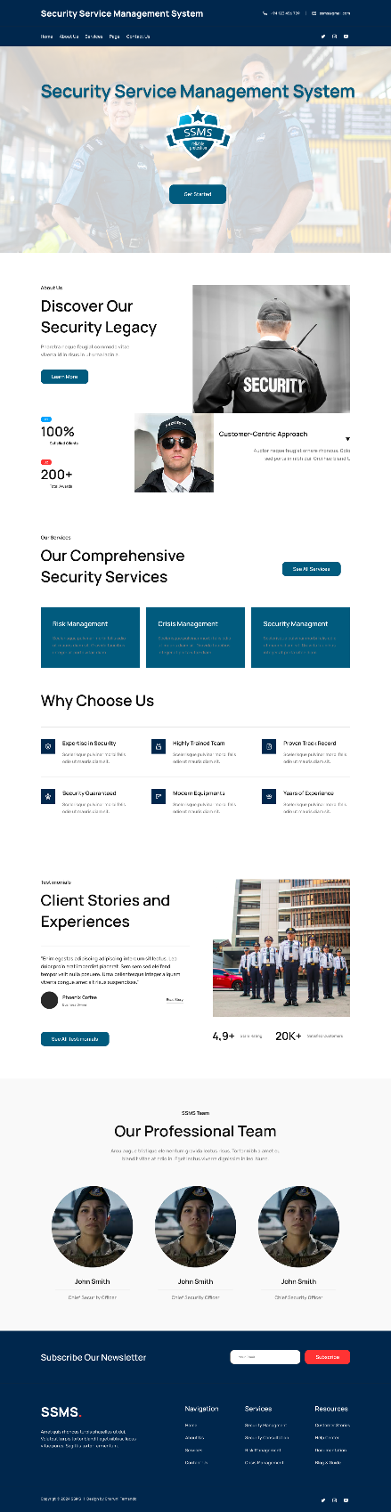

## 

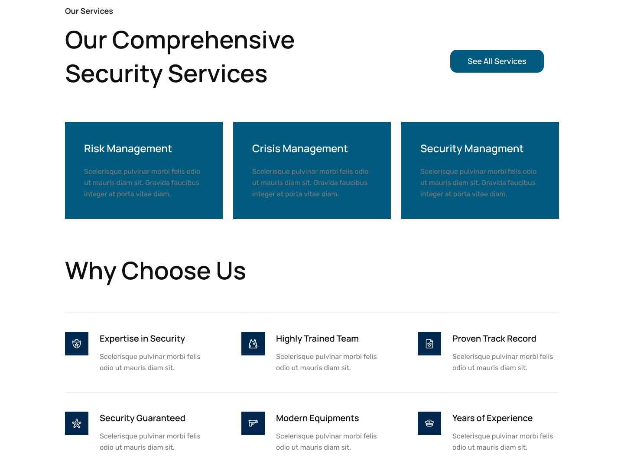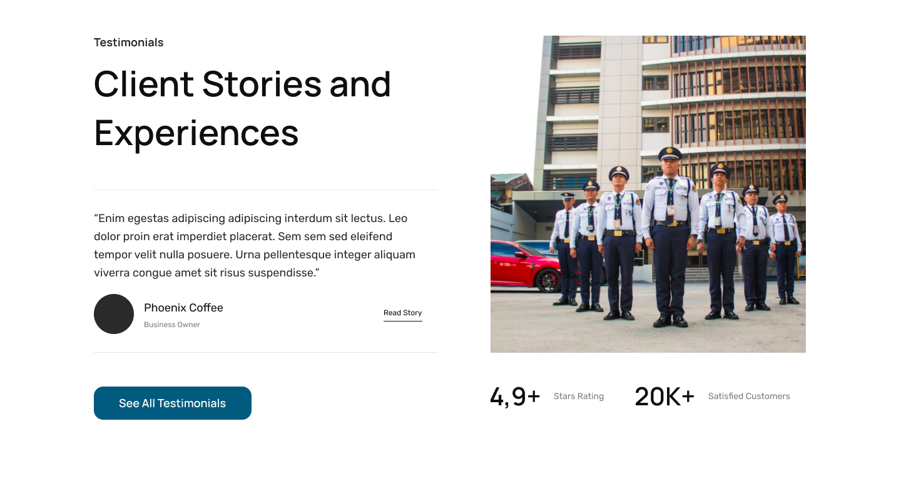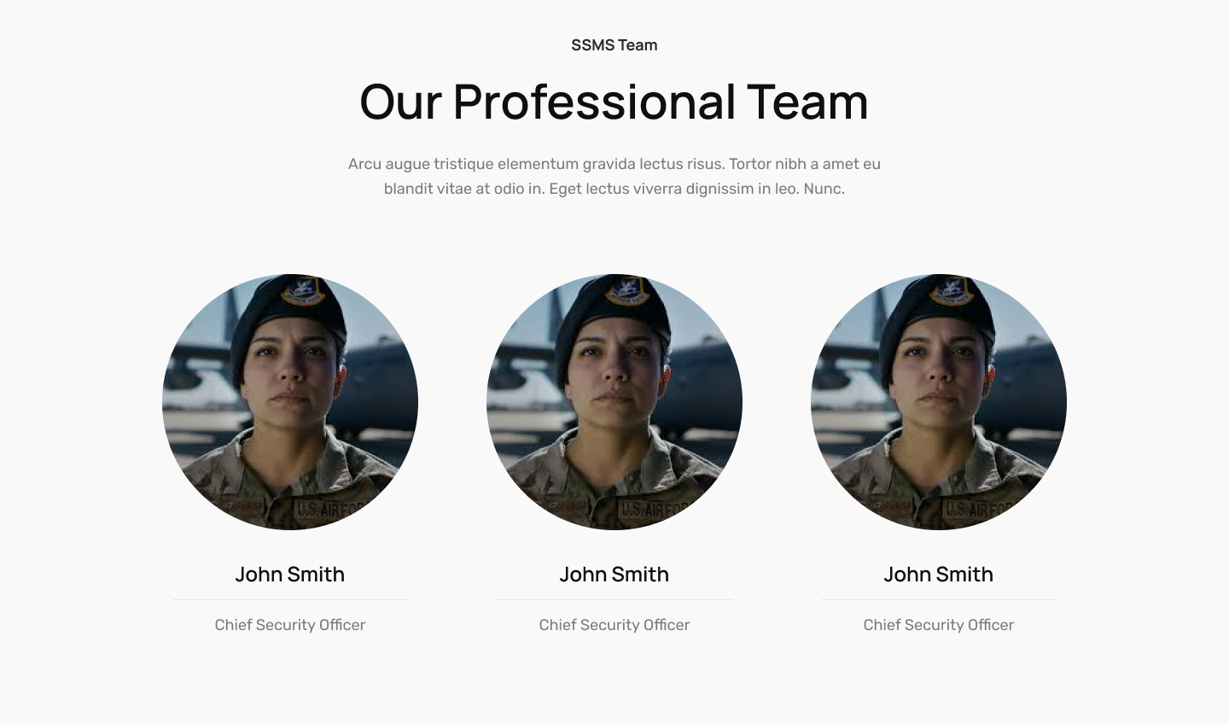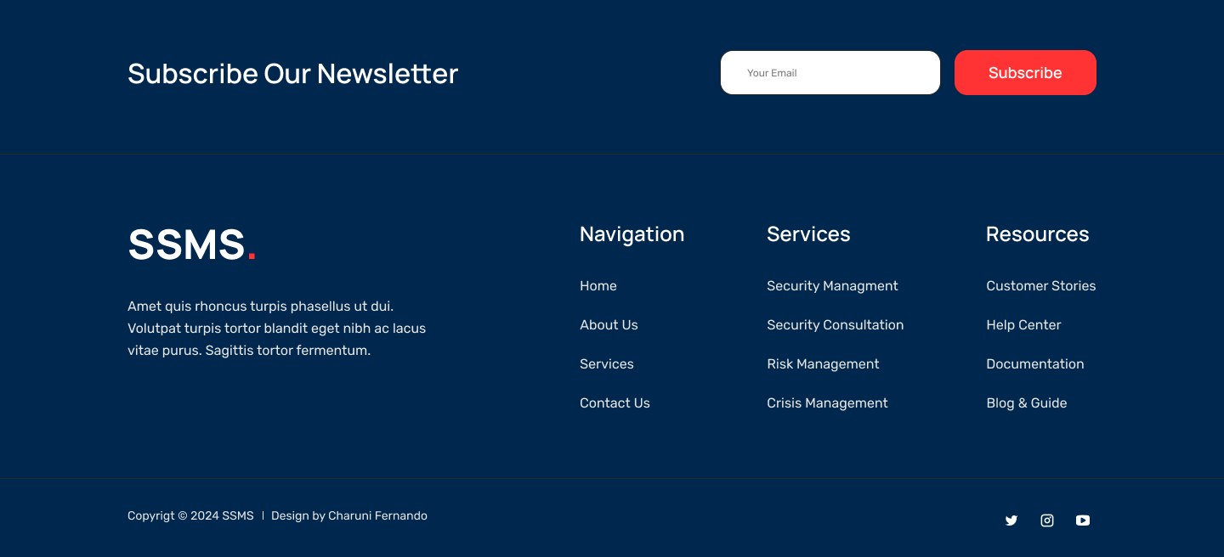

### Sign Up

### Sign In

### User Profile

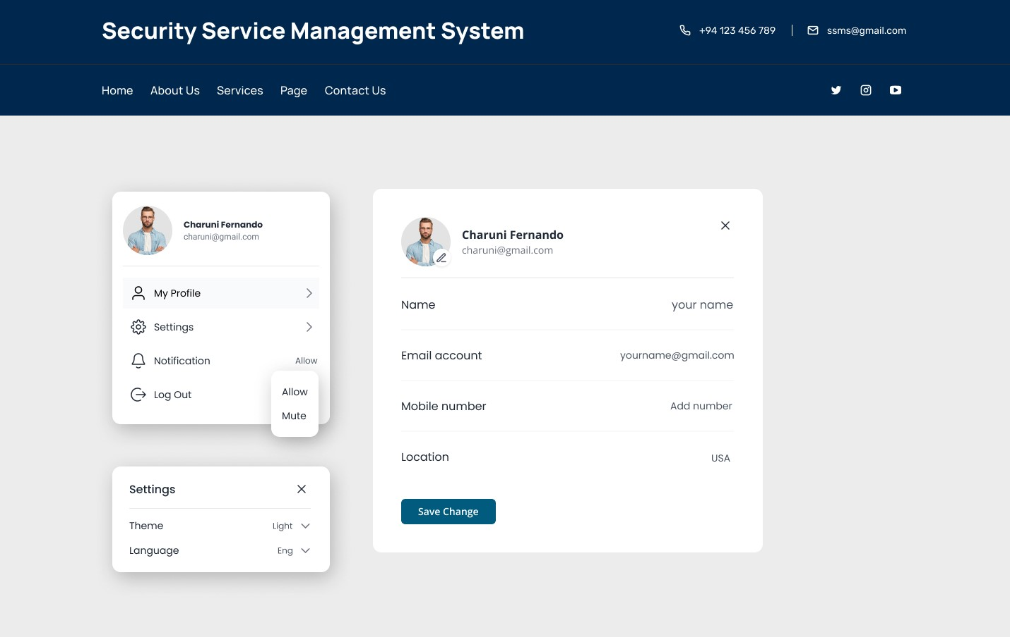

### User Dashboard

### Add User

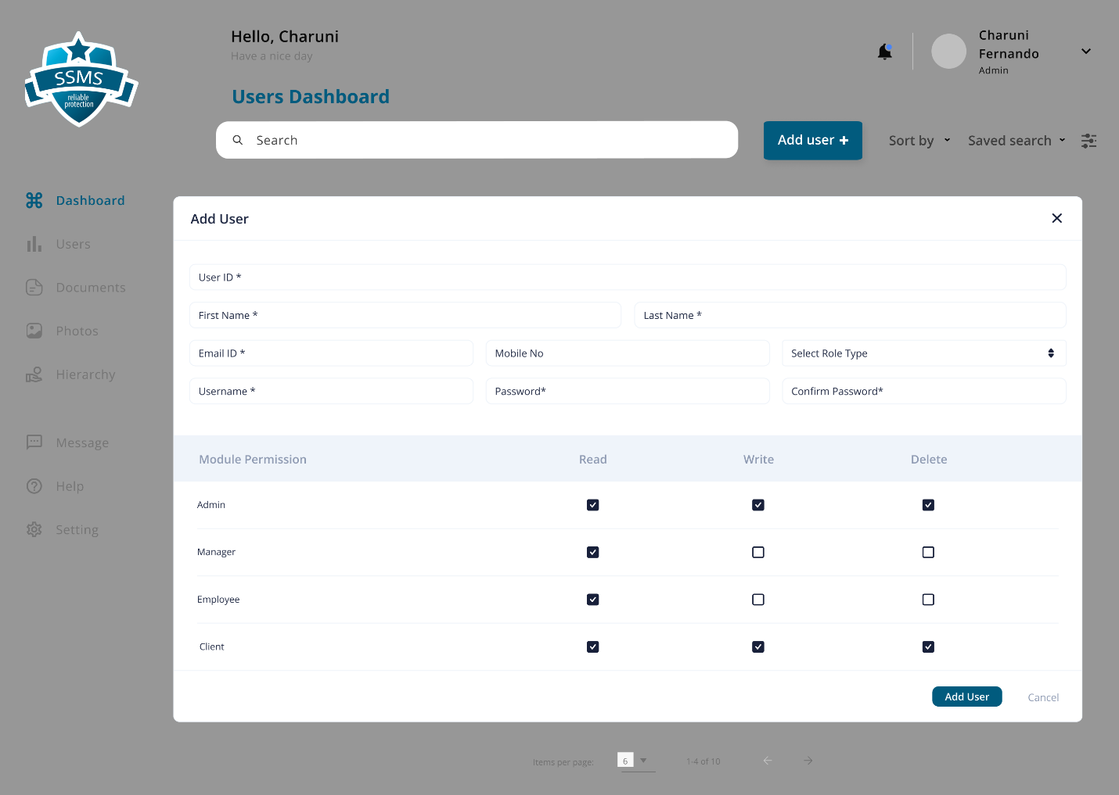

### Users

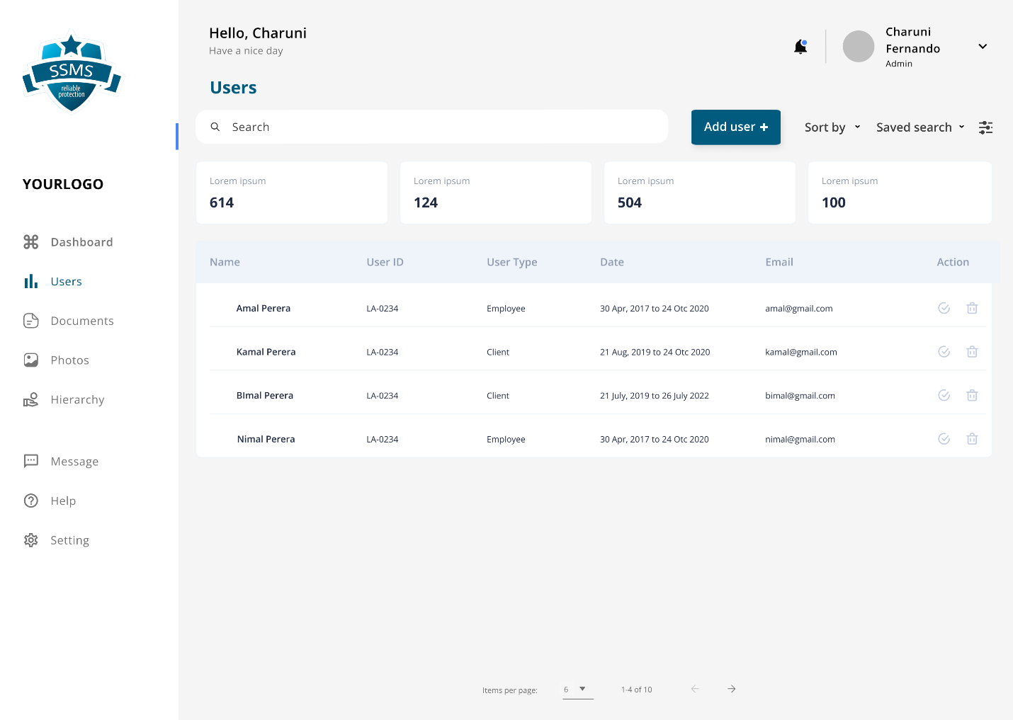

### Documentation

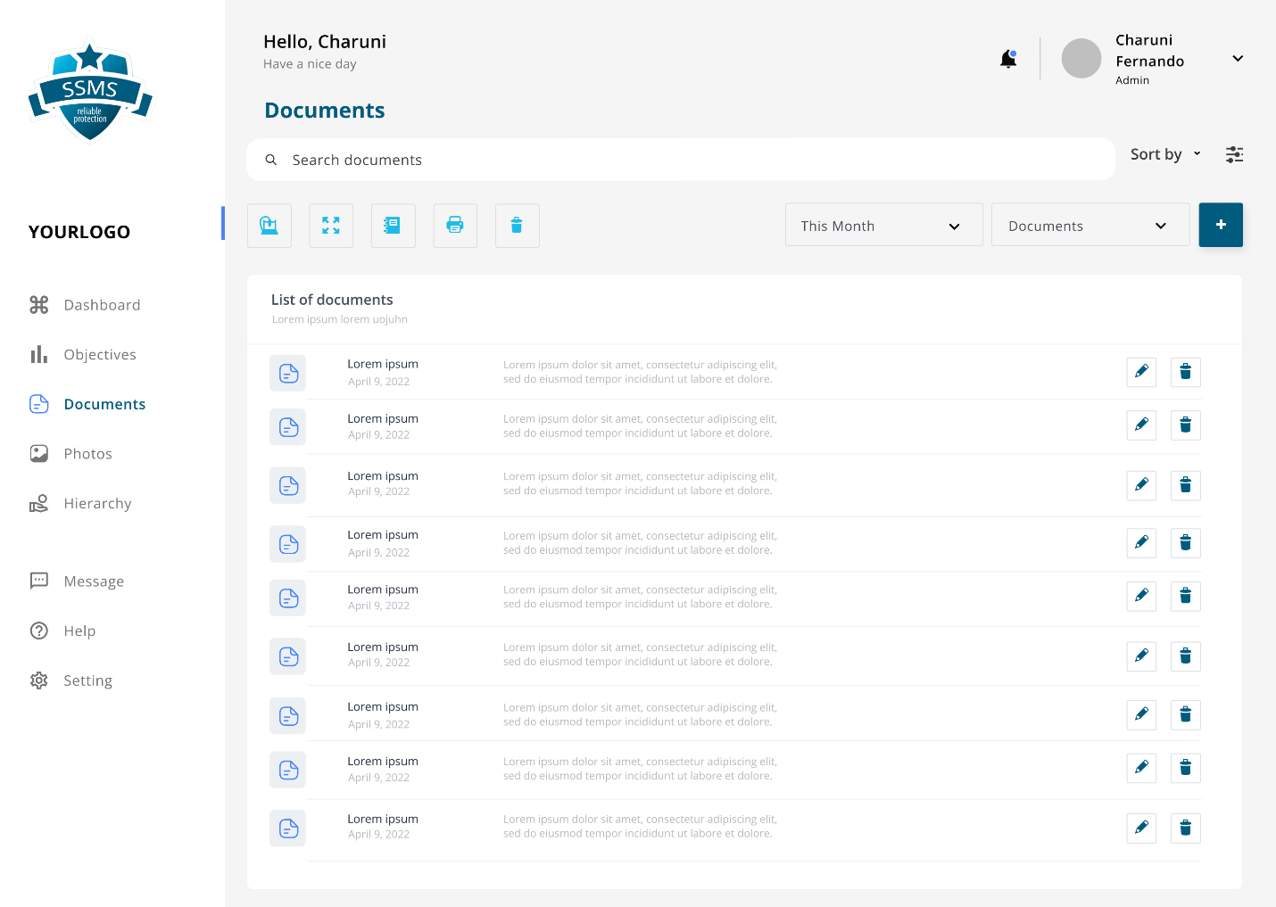

## IT22907998 – Sadisha R. M. M | Training Management

### Course Dashboard



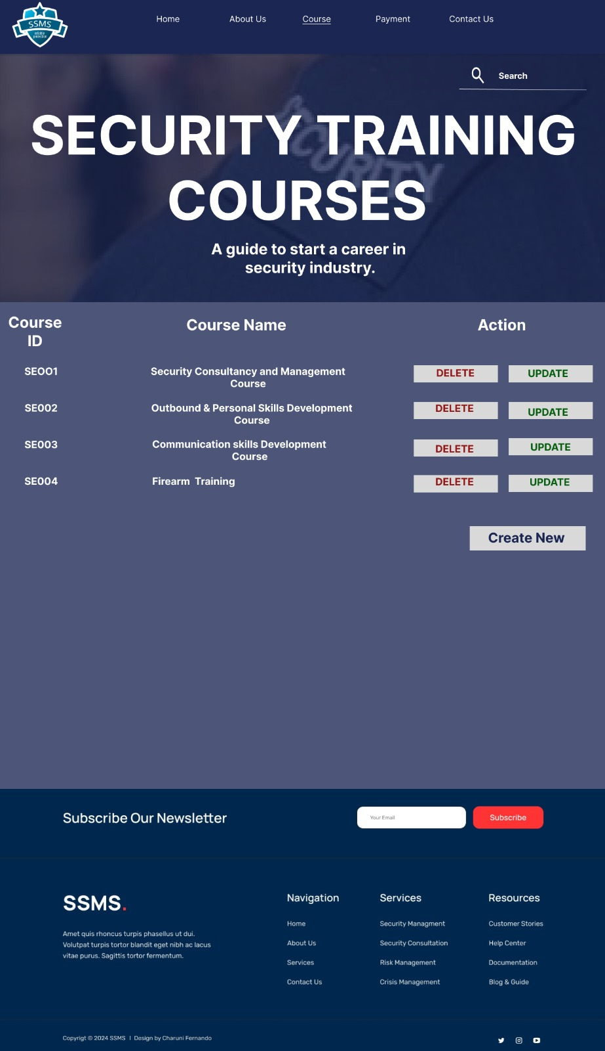

### Courses

### 

### 



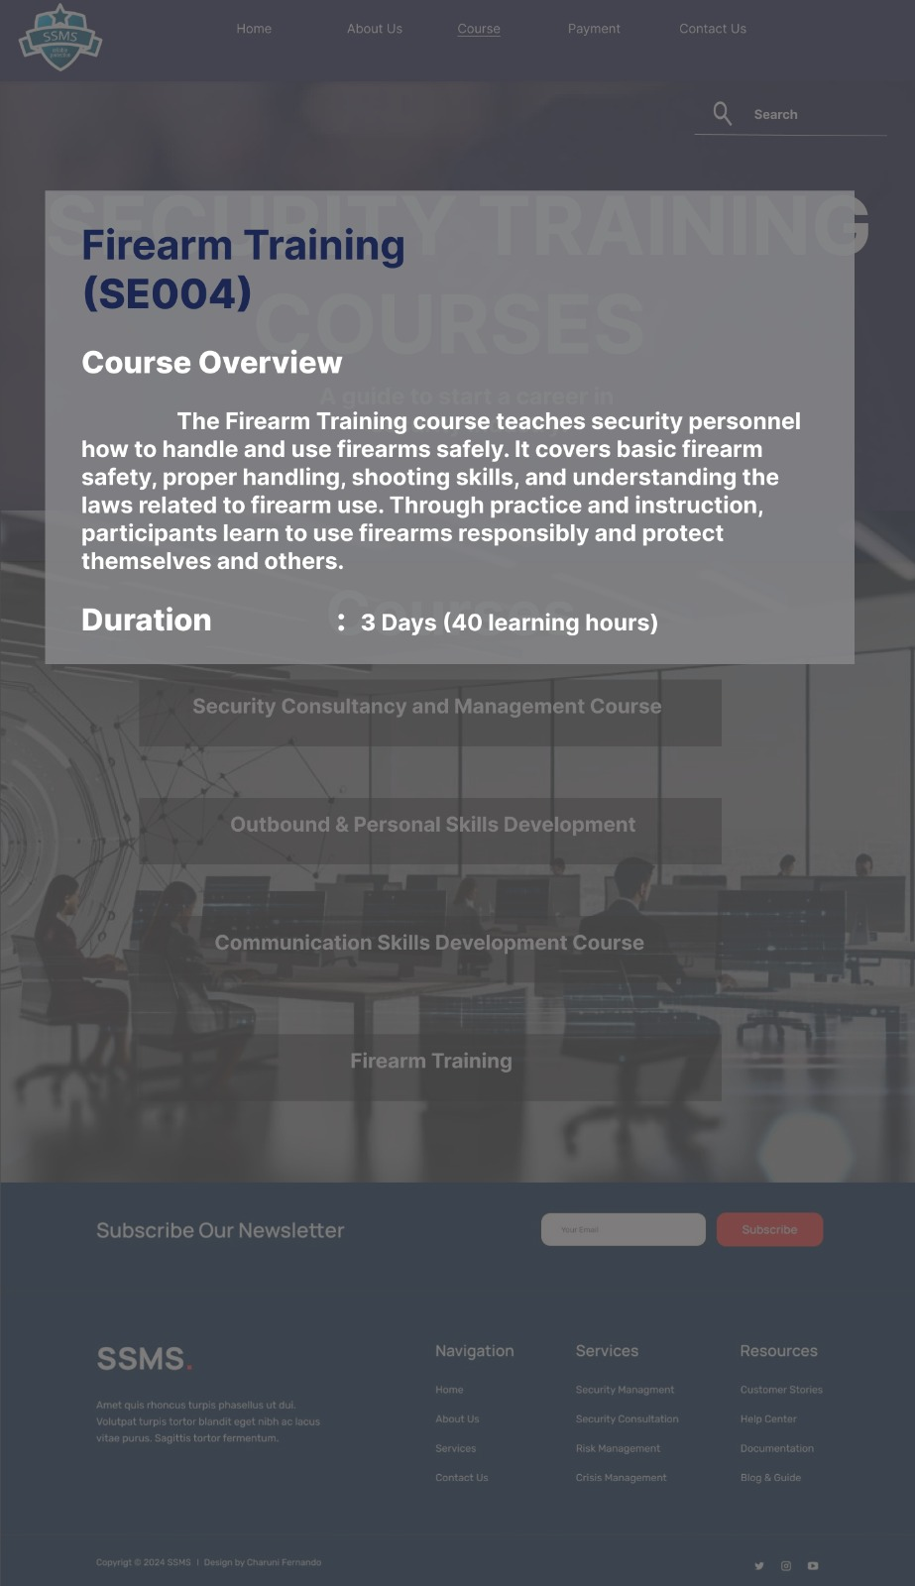

## IT20145552 – Dissanayaka D. M. S. M | Client Management

### Client Inquiry Dashboard

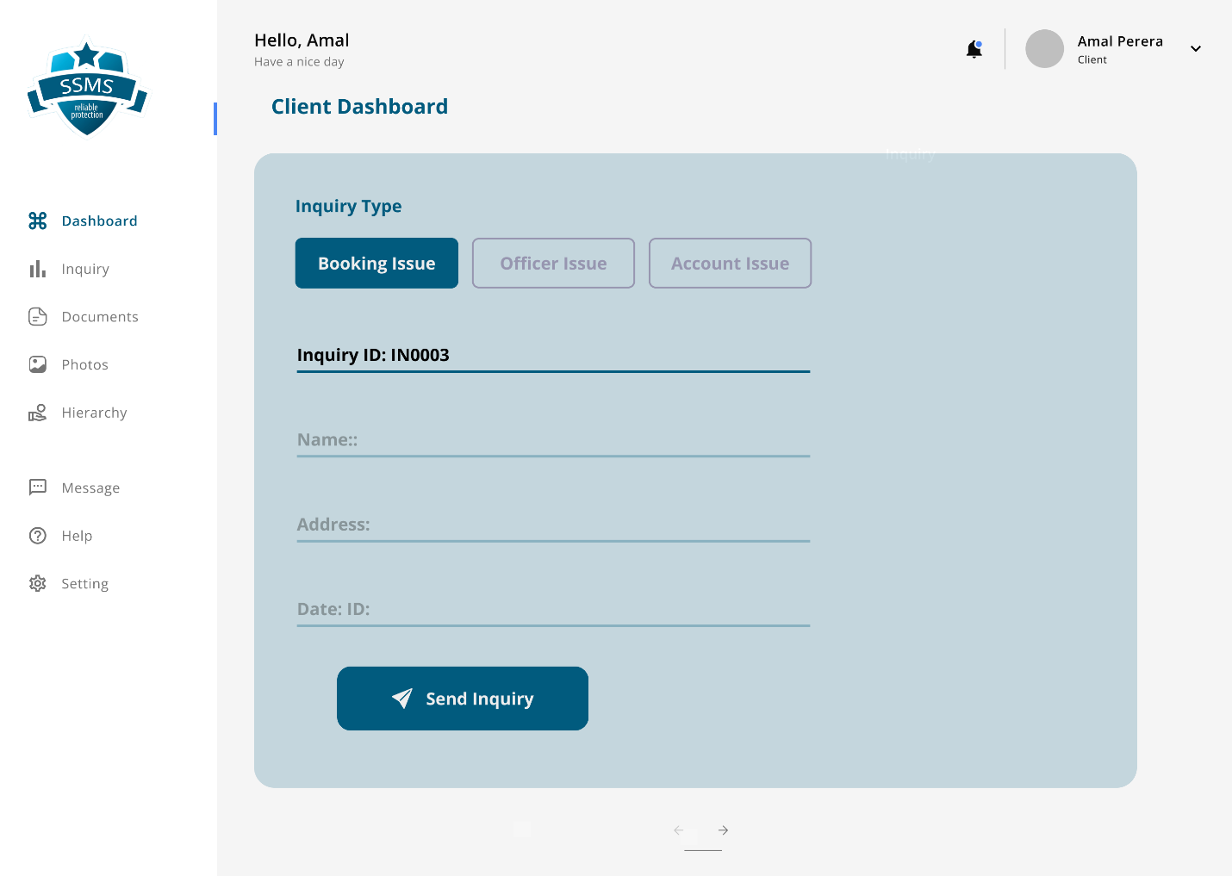

### Client Manager Dashboard

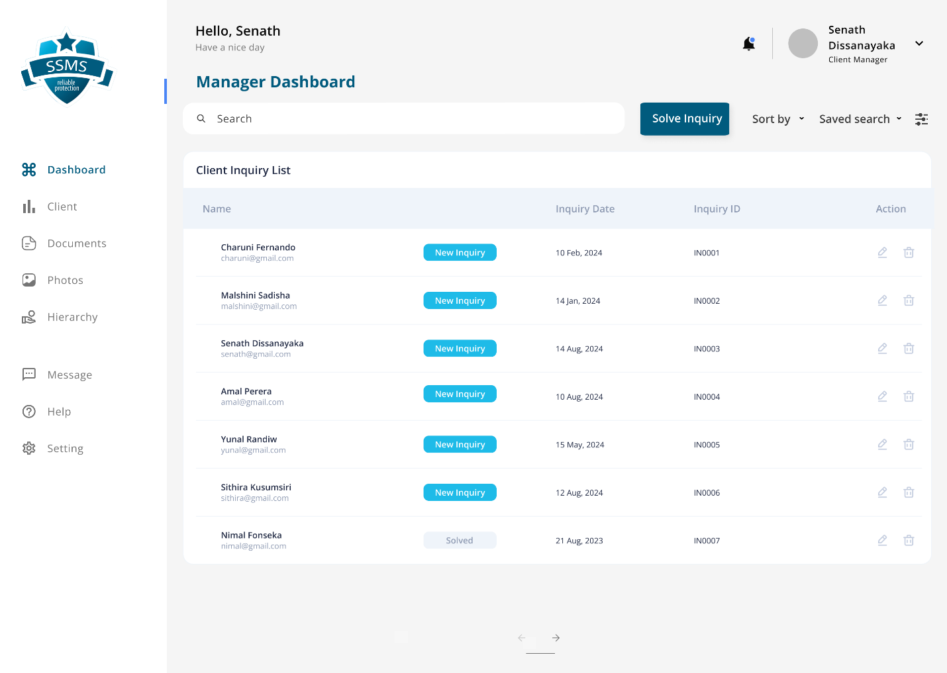

### Solve Inquiry

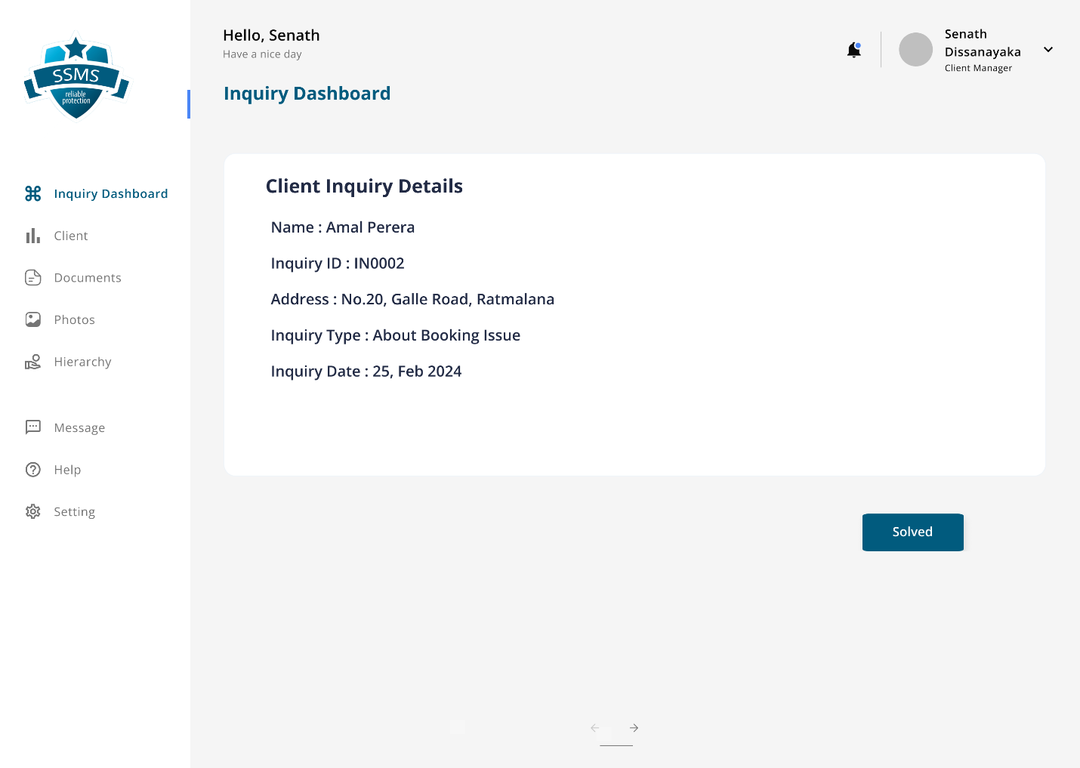

## IT22257086 – Randiw. E. Y | Booking Management

### Bookings

### Clients

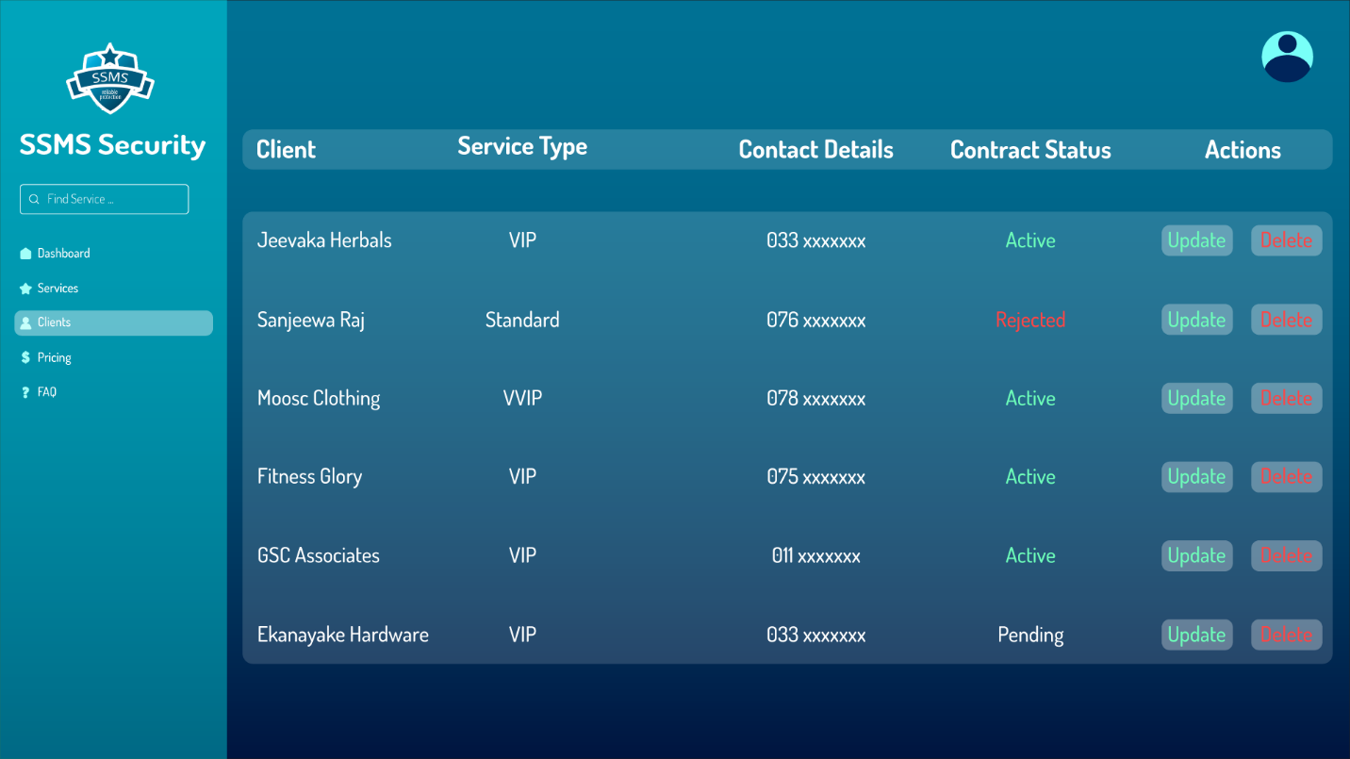

### Booking Dash

## IT22293480 – Jayodhya J. D. H | Payment Management

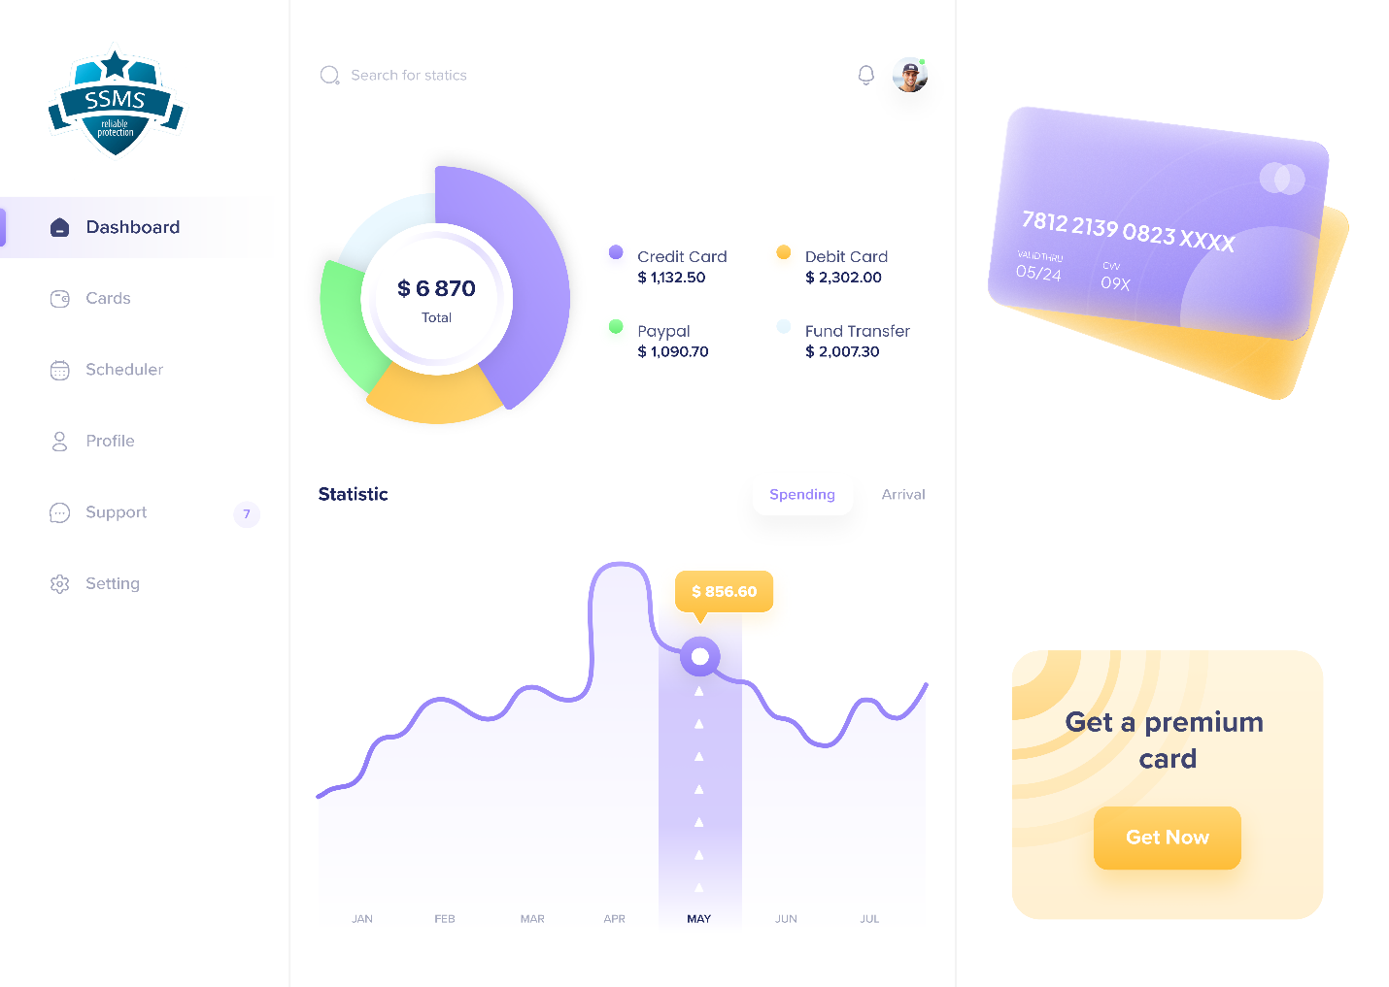

## IT22127082 – Medawatte W. W. M. T. N. B | Operation Management

### Operation Manager Dashboard

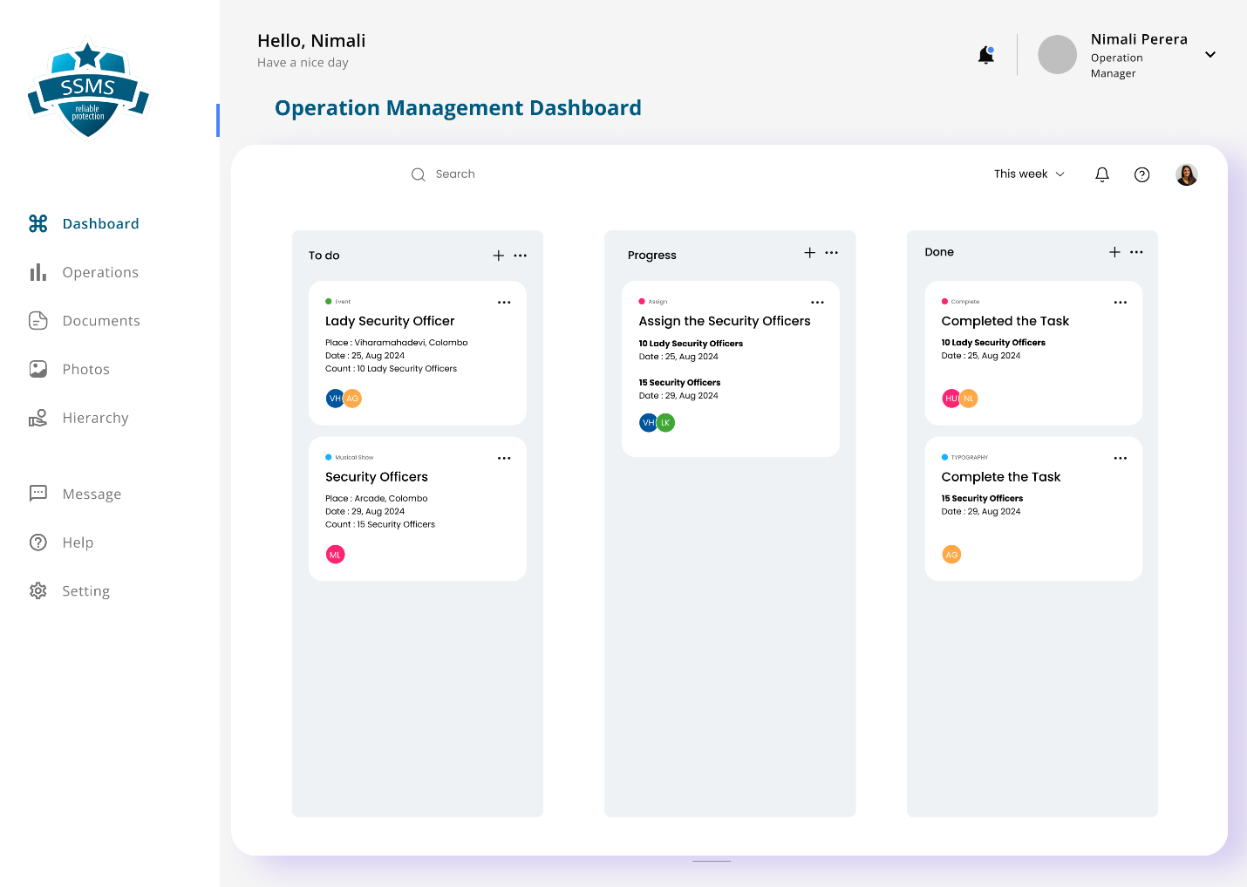

## IT22132628 – Kusumsiri P. A. S. S | Inventory Management

### Inventory Home

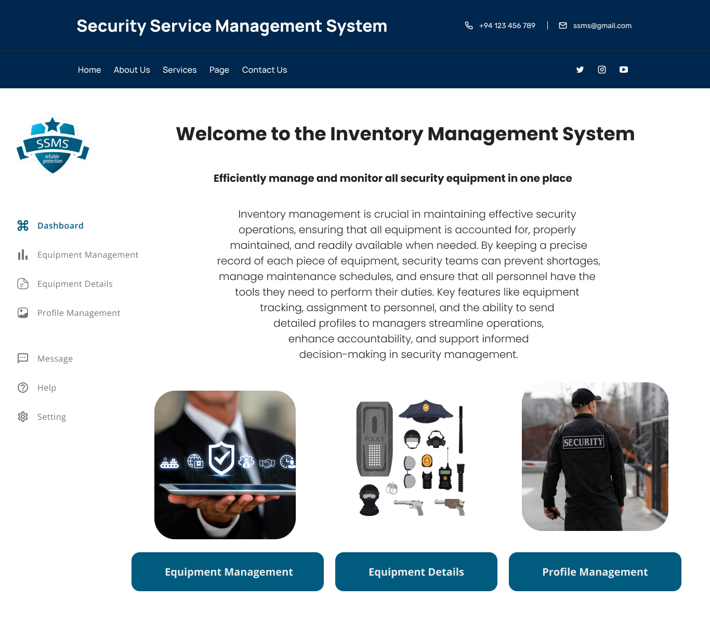

### Equipment Management

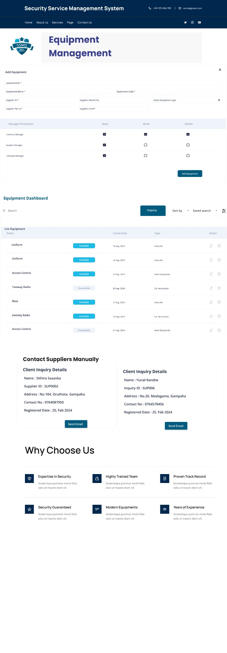

### Out of Stock

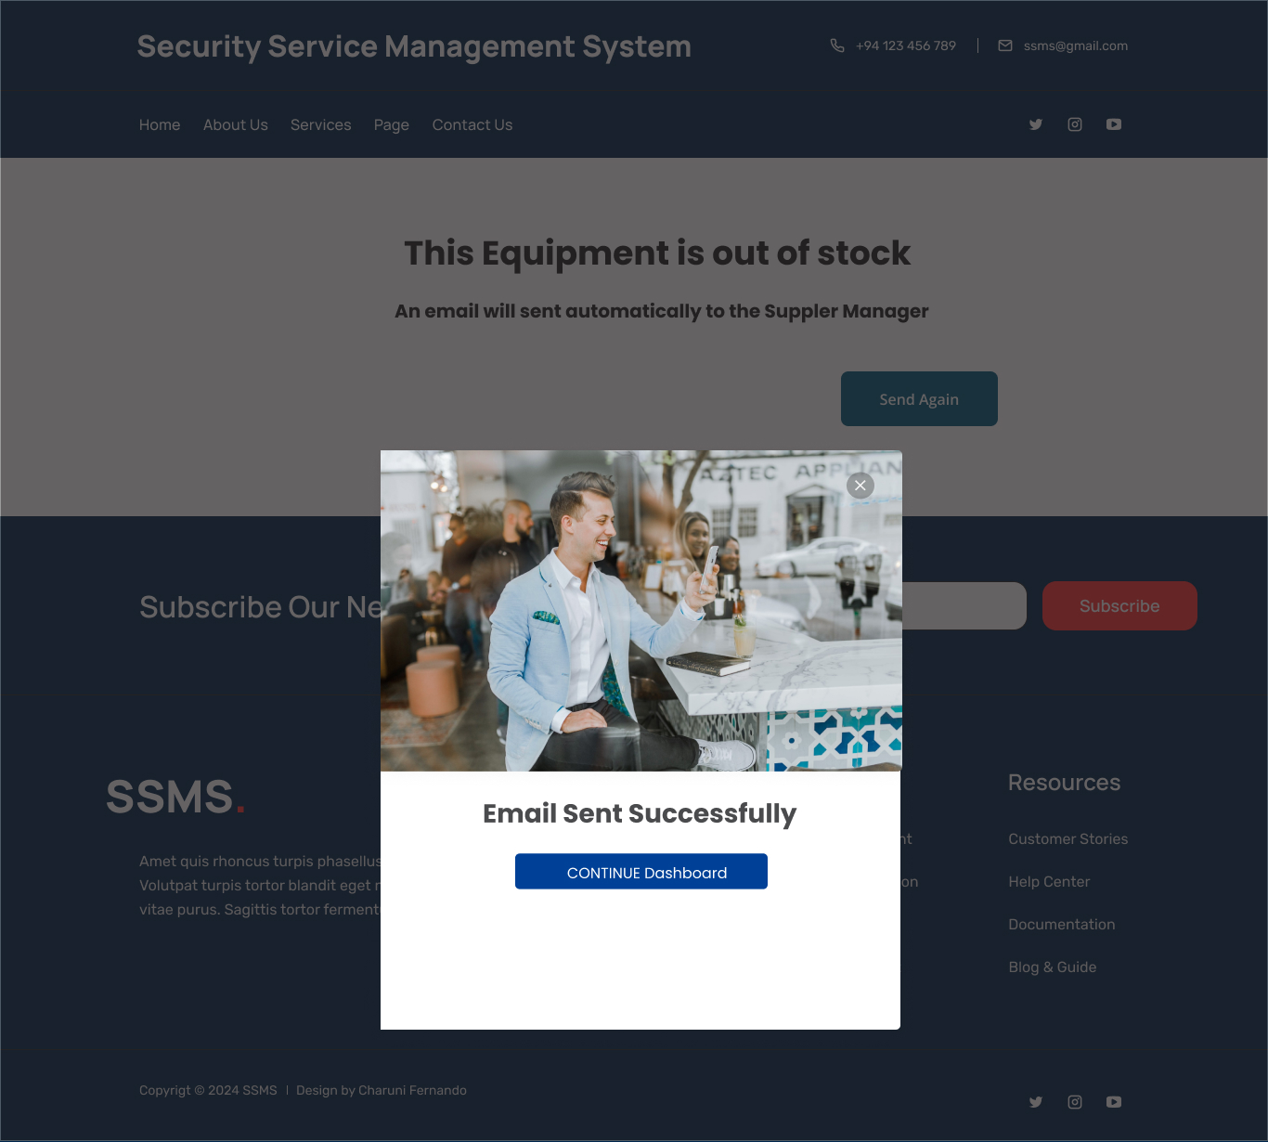

### Equipment Details

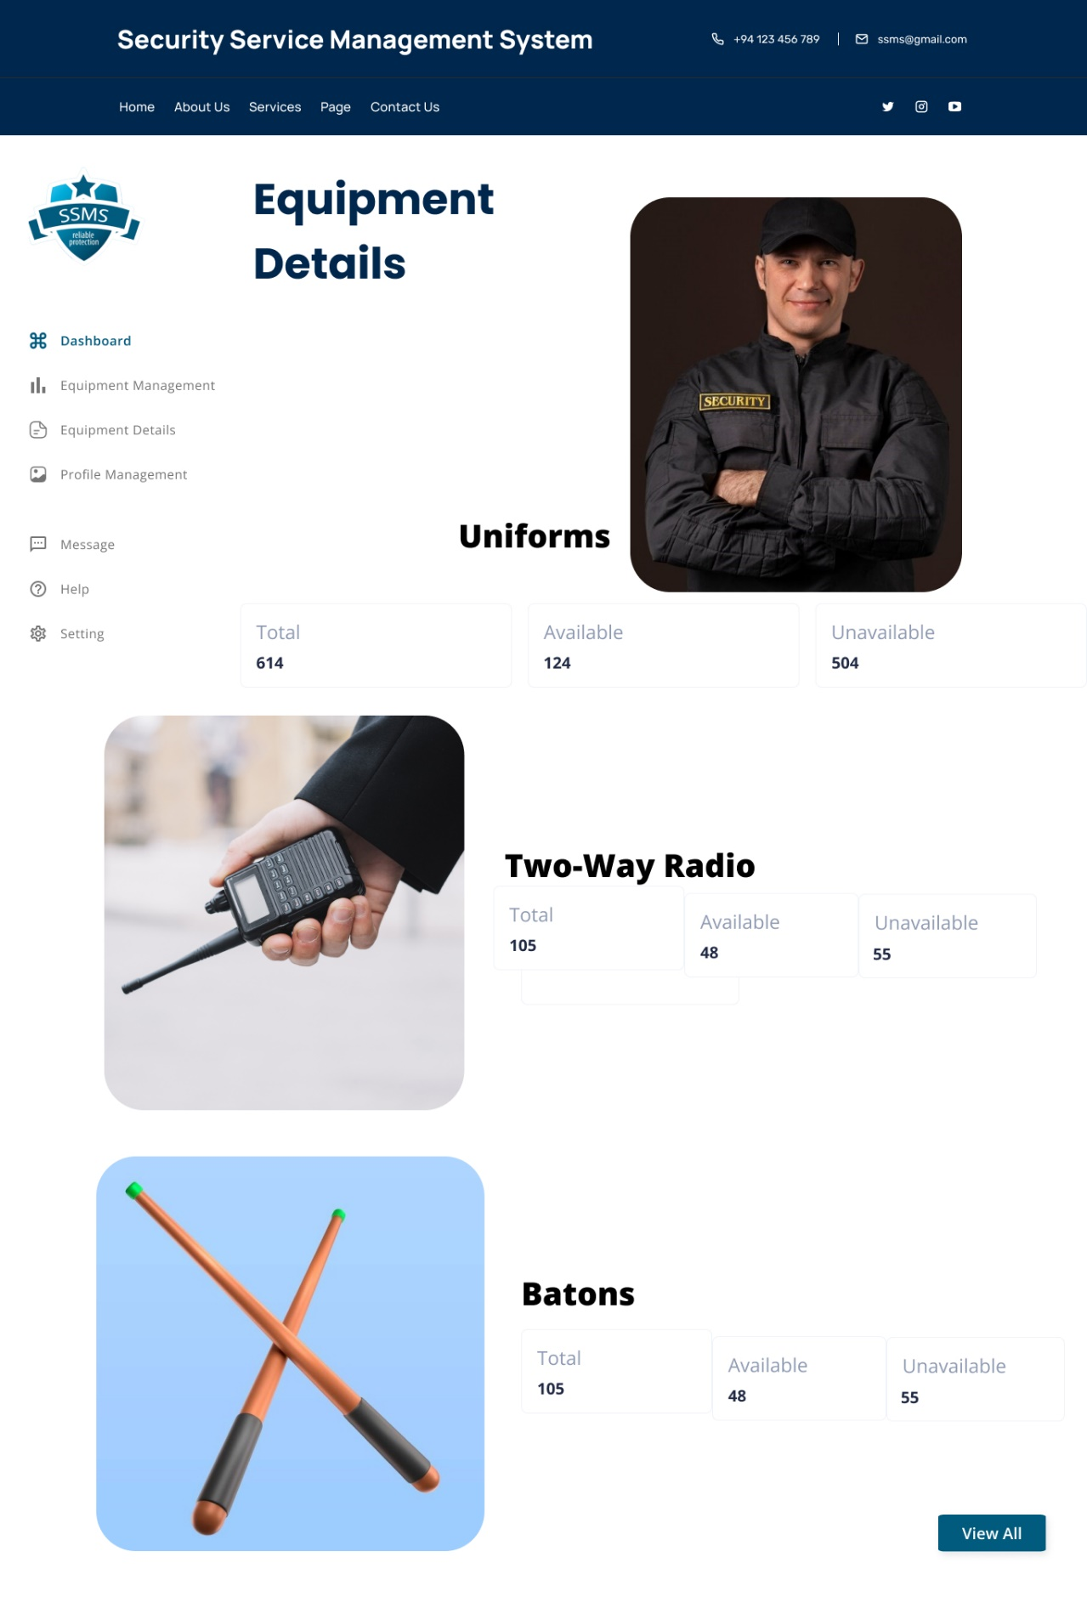

### Profile Management

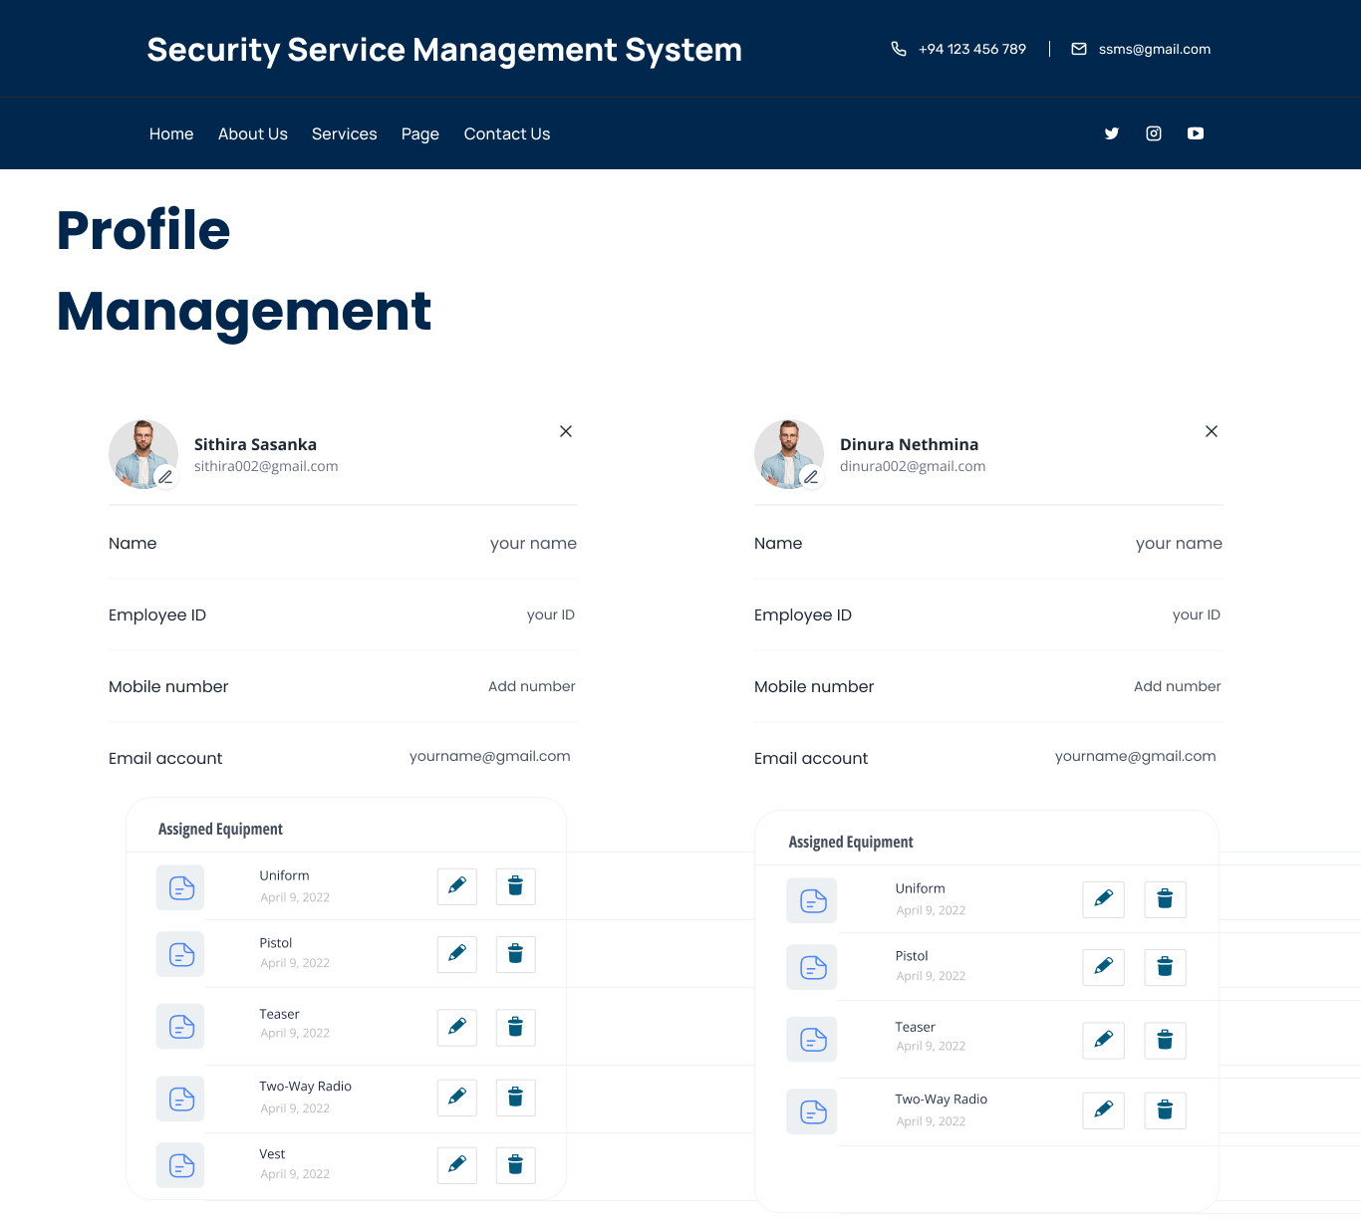

## IT22197146 – Ranasinghe R. A. R. V. C | Leave Management

### Leave Request Form

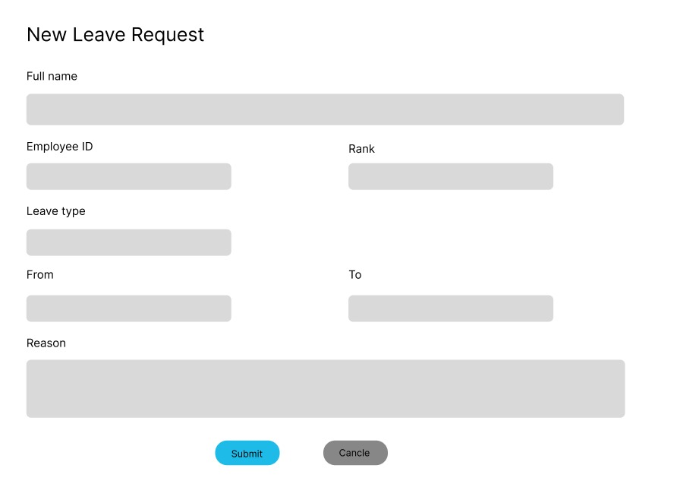

### Leave Request Dashboard

### 

# UML Diagrams

## IT22325228 – Fernando K. K. C | User Management

### Class Diagram

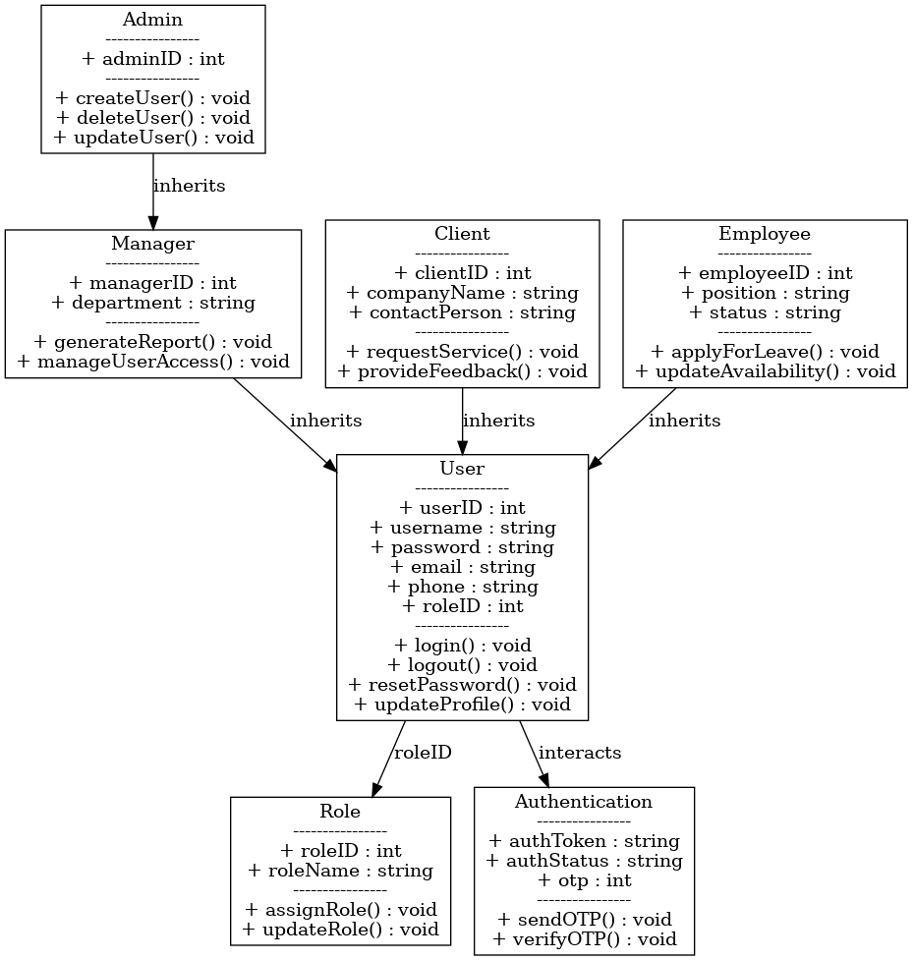

### Sequence Diagram

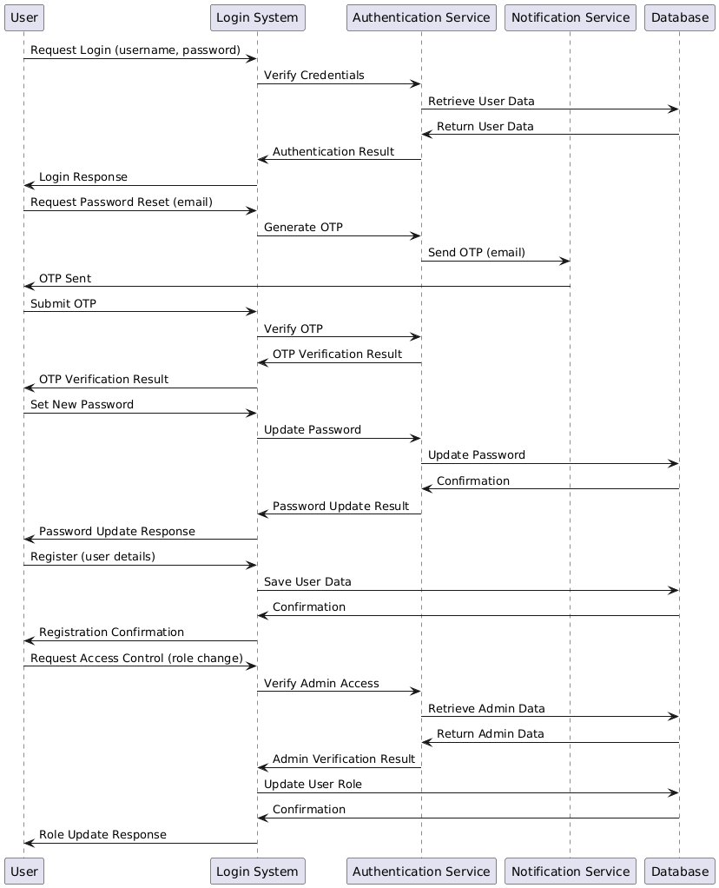

### Activity Diagram

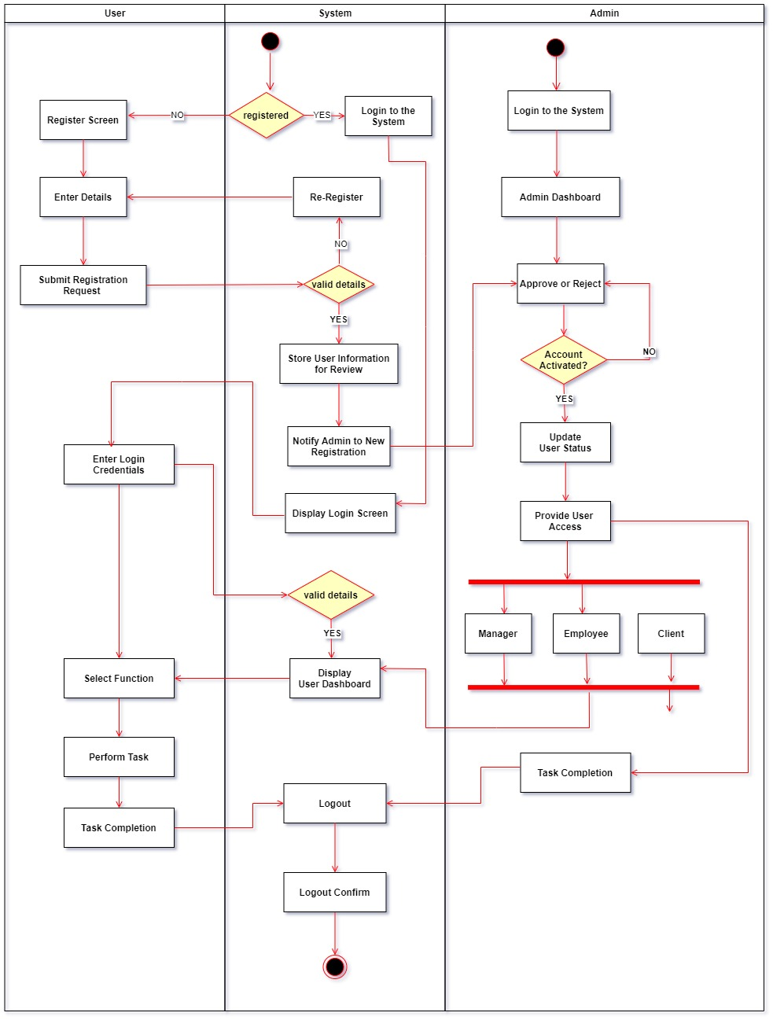

### ER Diagram

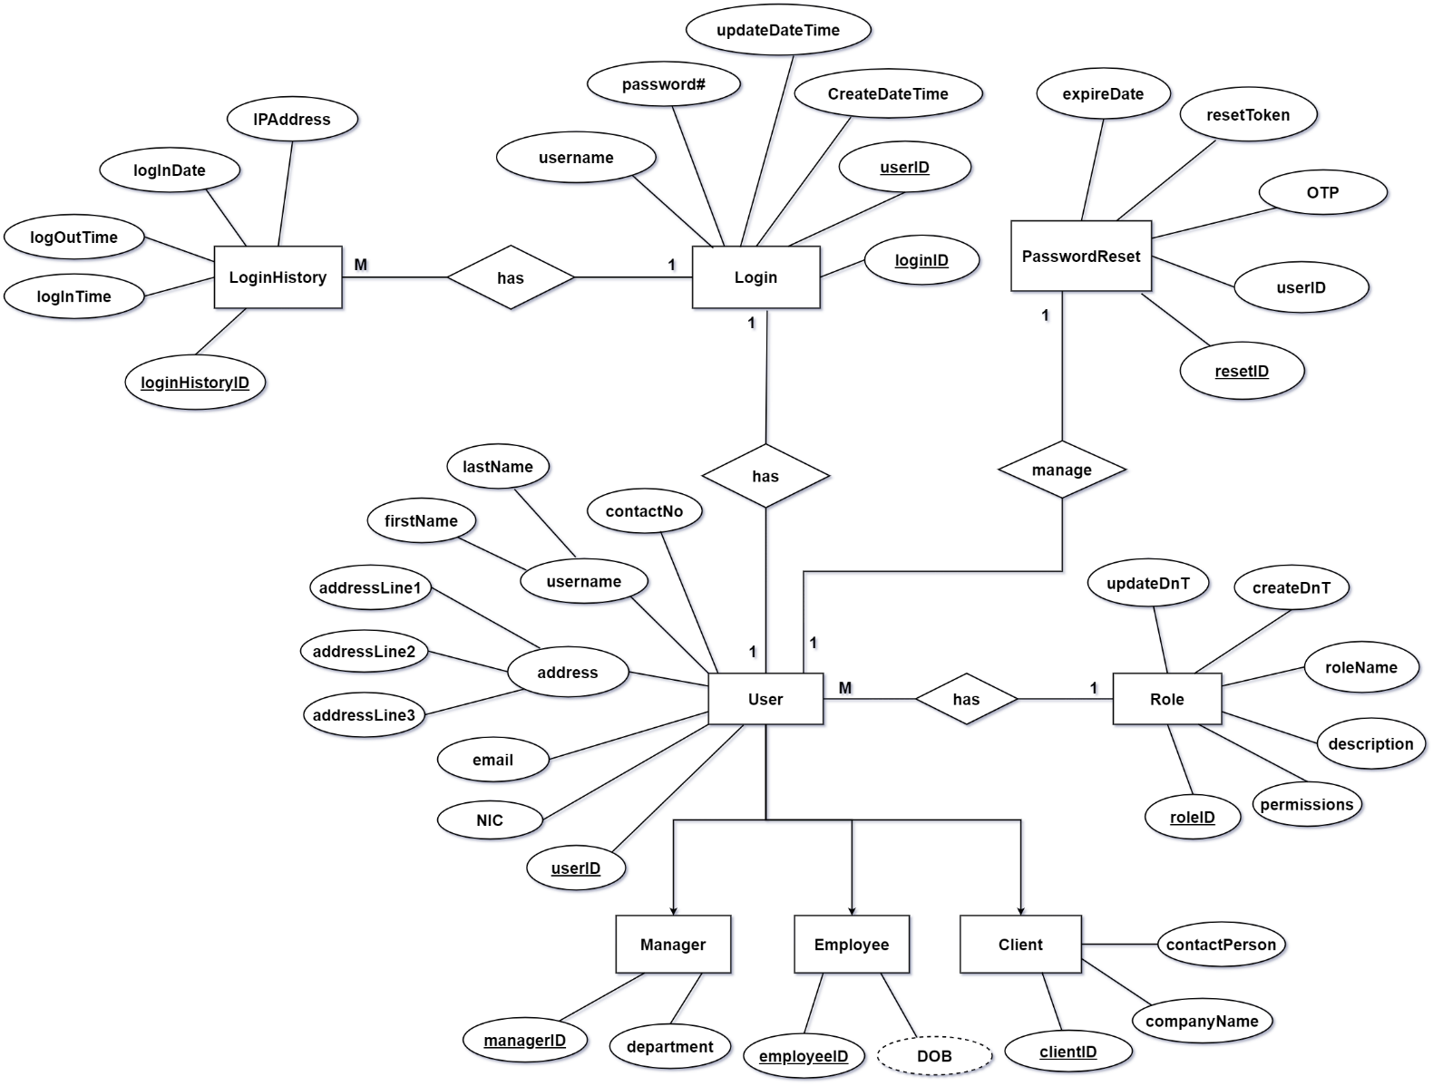

## IT22907998 – Sadisha R. M. M | Training Management

### Class Diagram

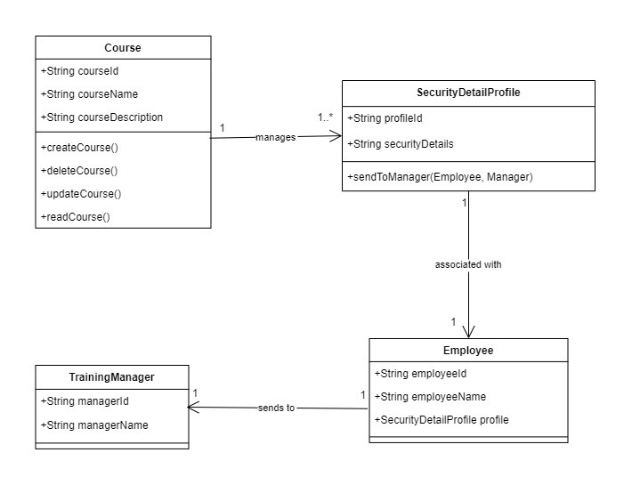

### Sequence Diagram

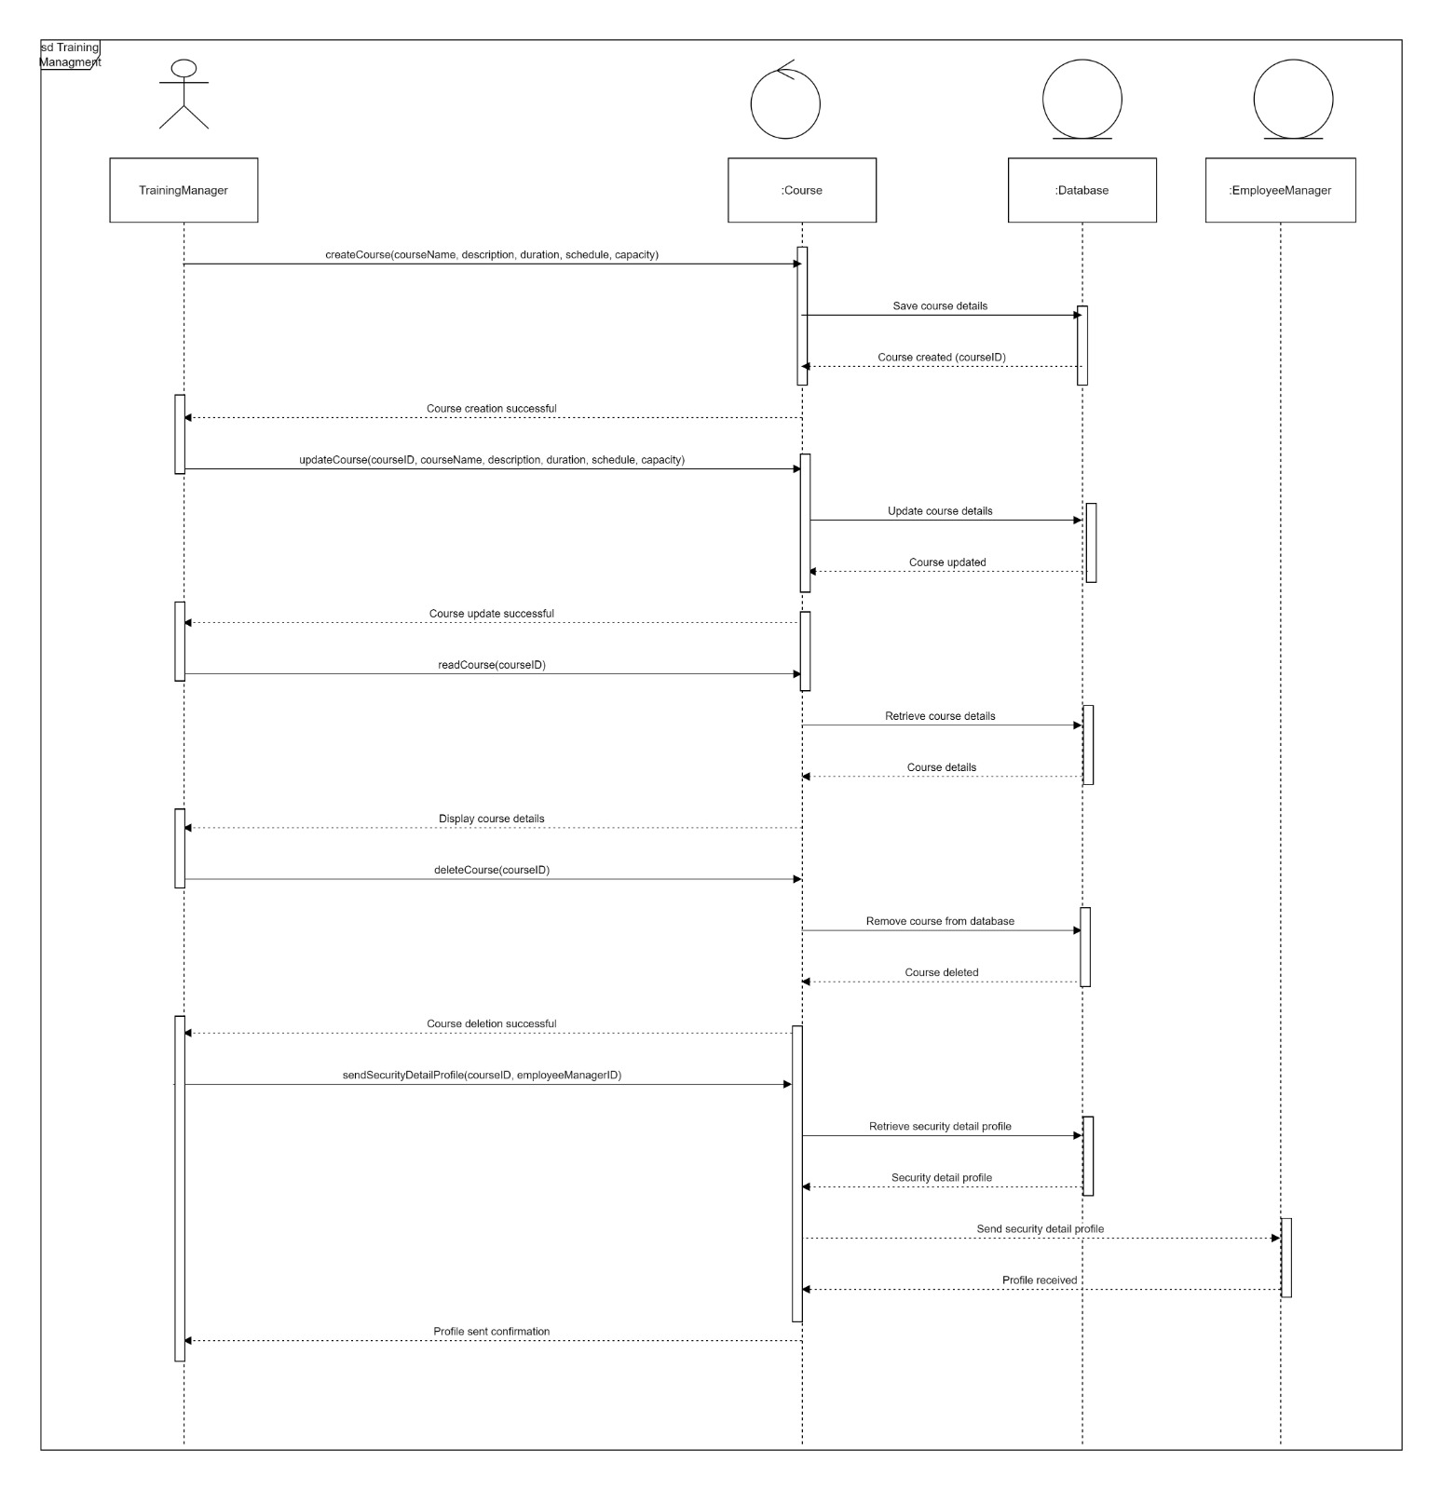

### Activity Diagram

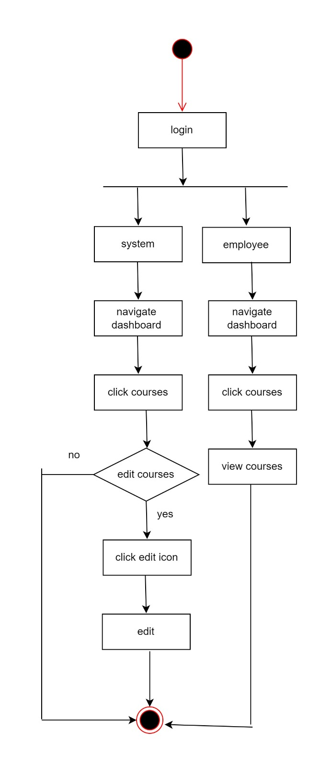

### ER Diagram

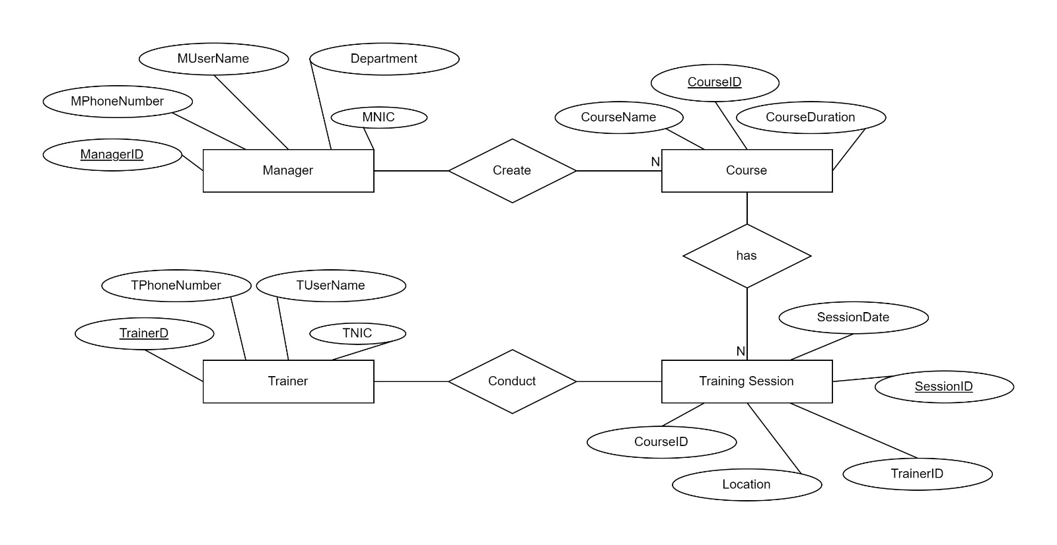

## IT20145552 – Dissanayaka D. M. S. M | Client Management

### Class Diagram

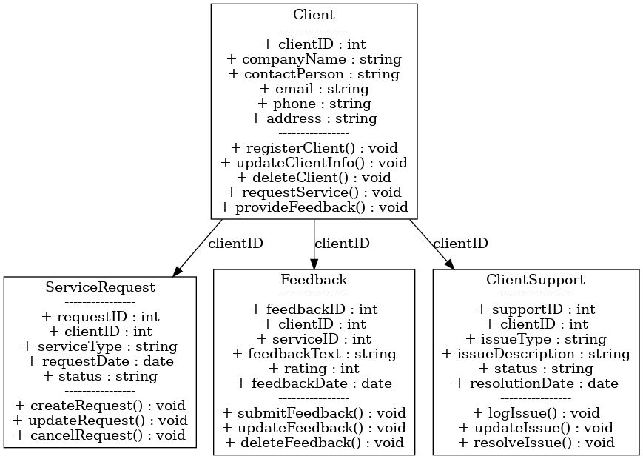

### Sequence Diagram

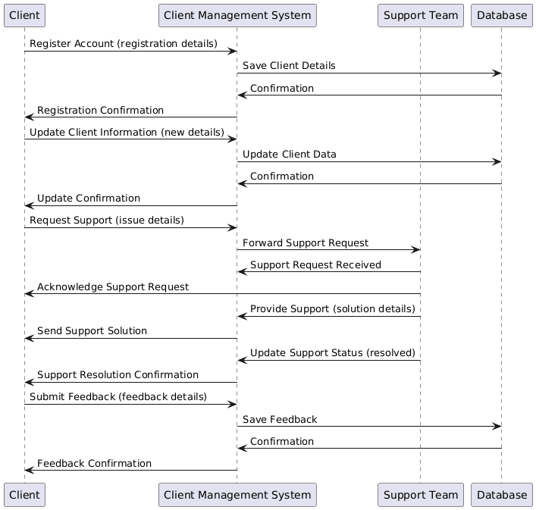

### Activity Diagram

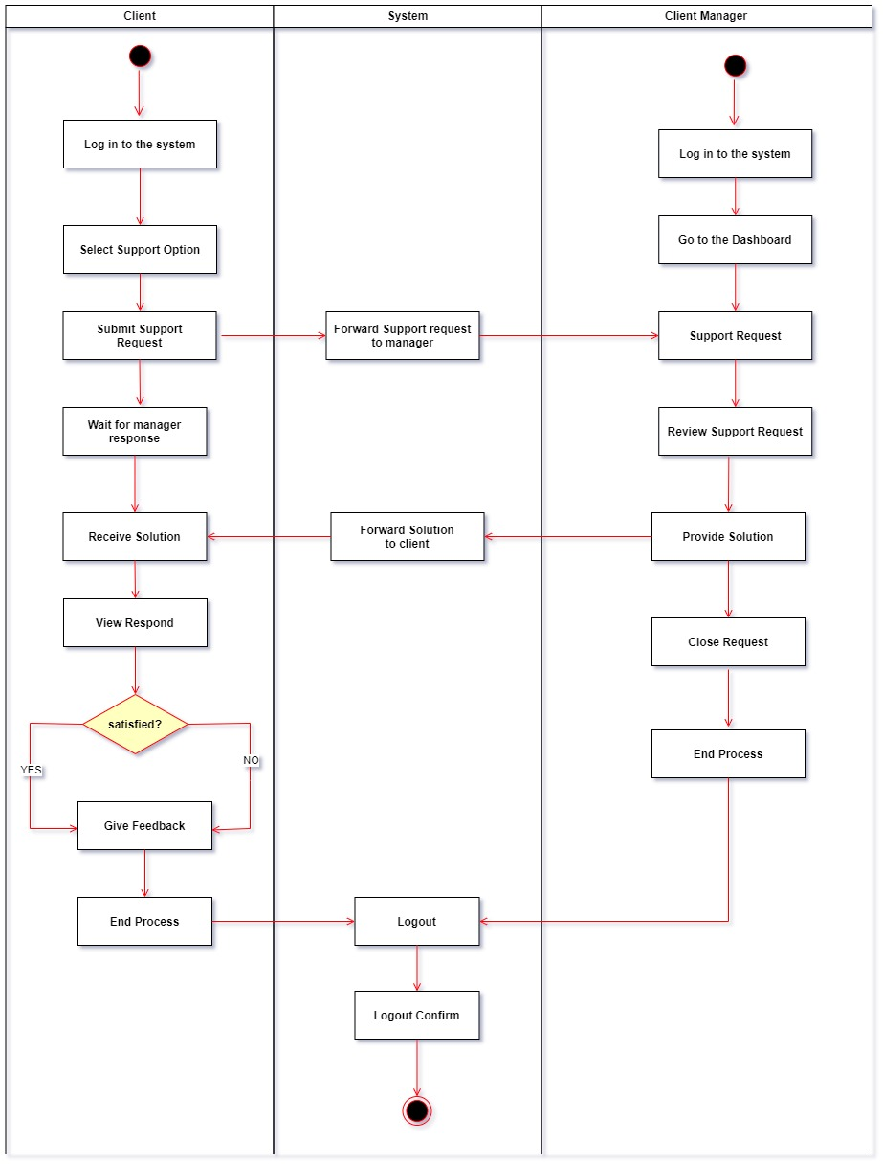

### ER Diagram

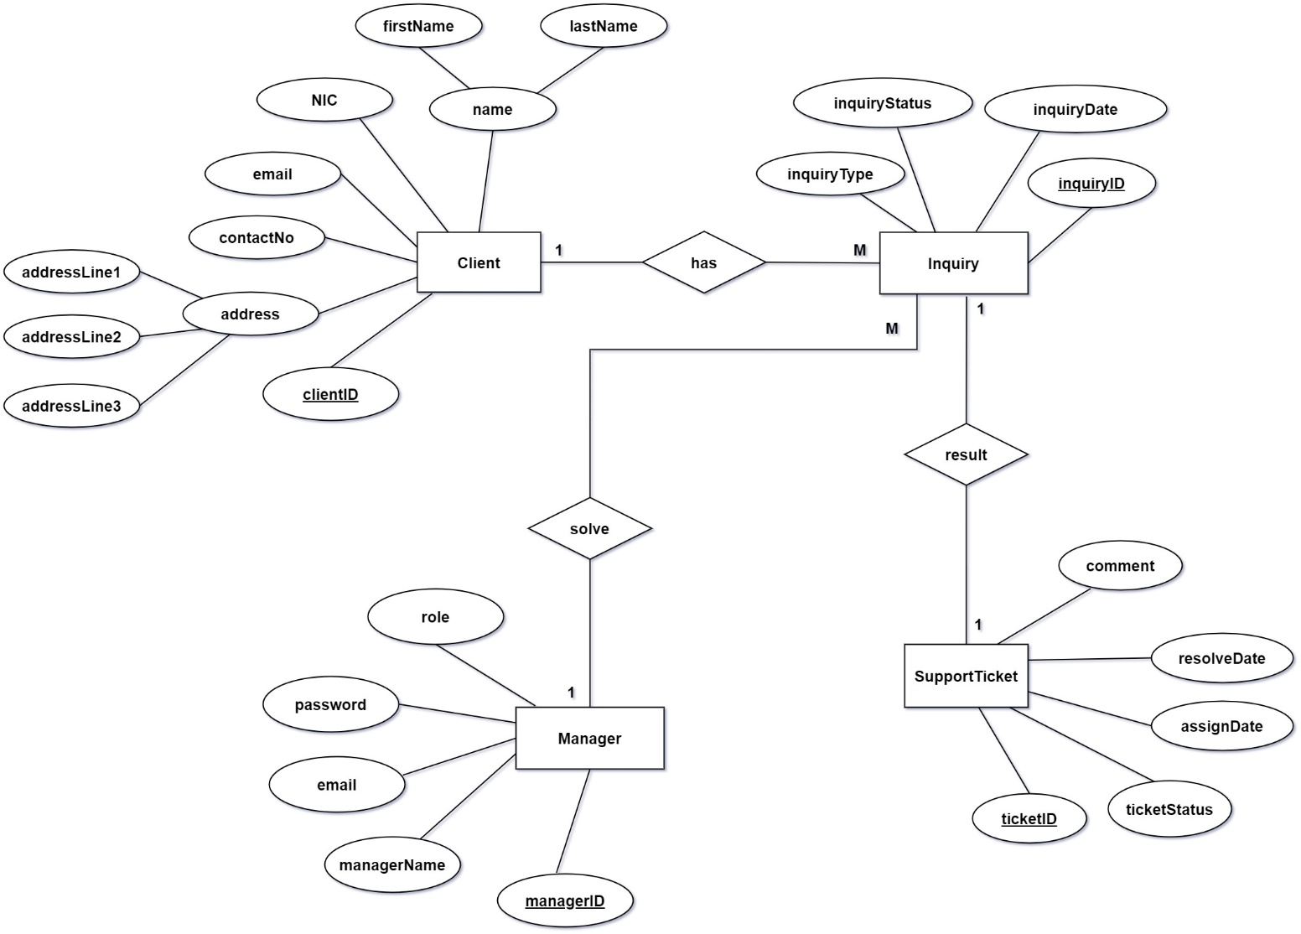

## IT22257086 – Randiw. E. Y | Booking Management

### Class Diagram

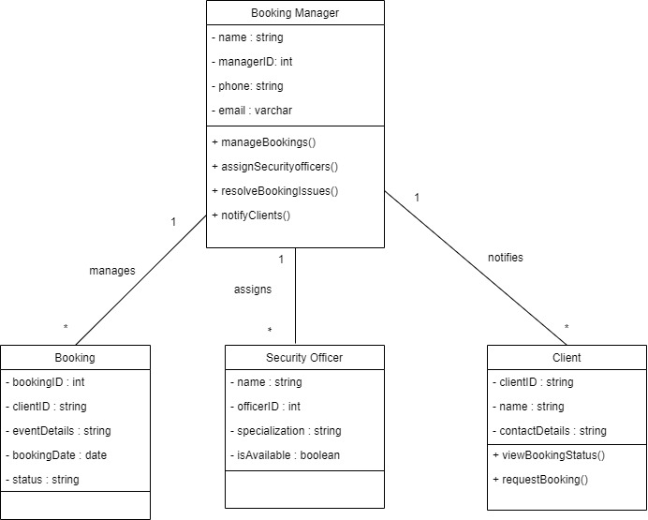

### Sequence Diagram

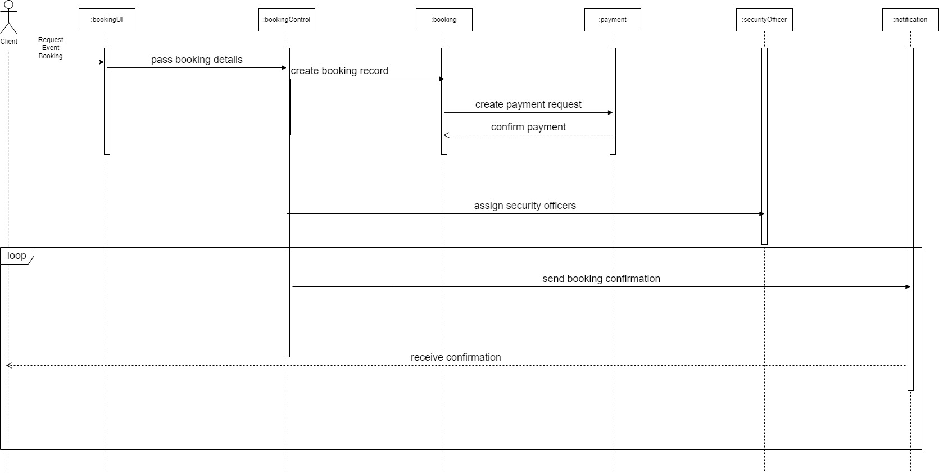

### Activity Diagram

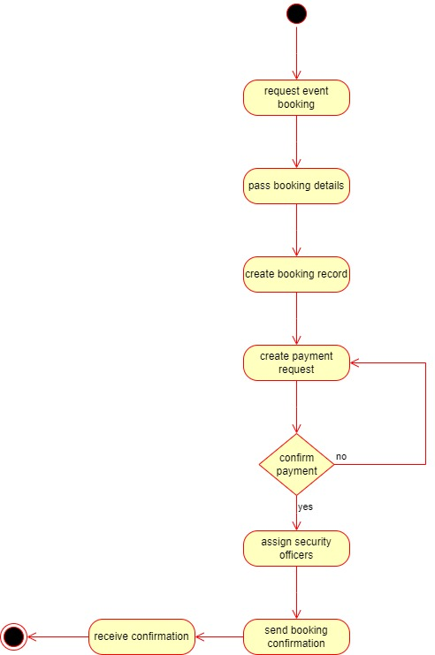

### ER Diagram

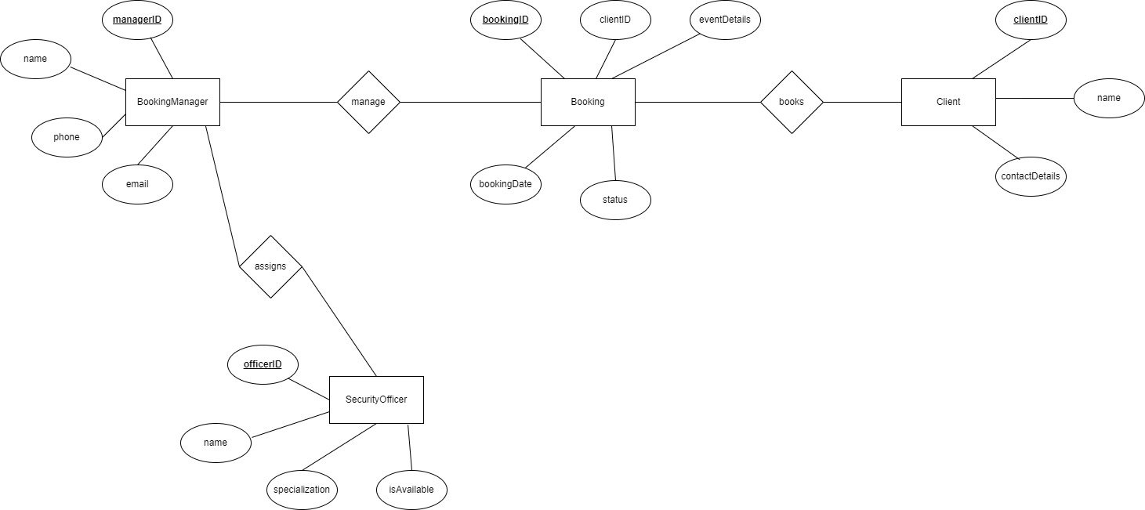

## IT22293480 – Jayodhya J. D. H | Payment Management

### Class Diagram

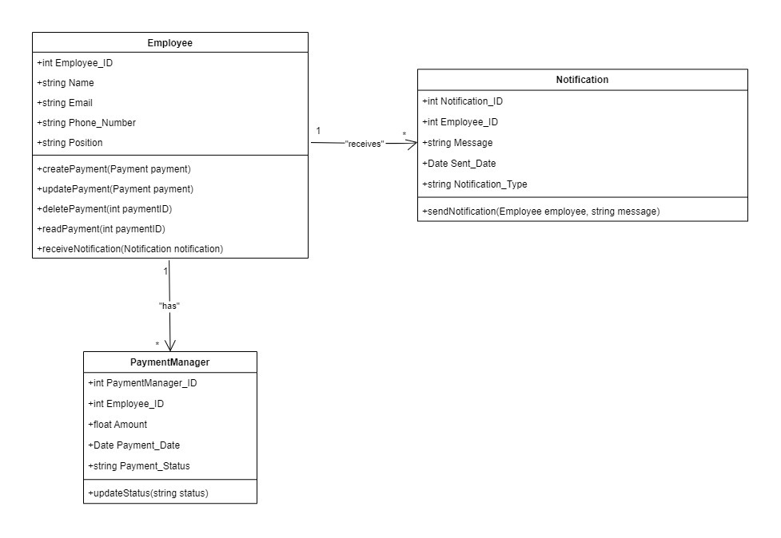

### Sequence Diagram

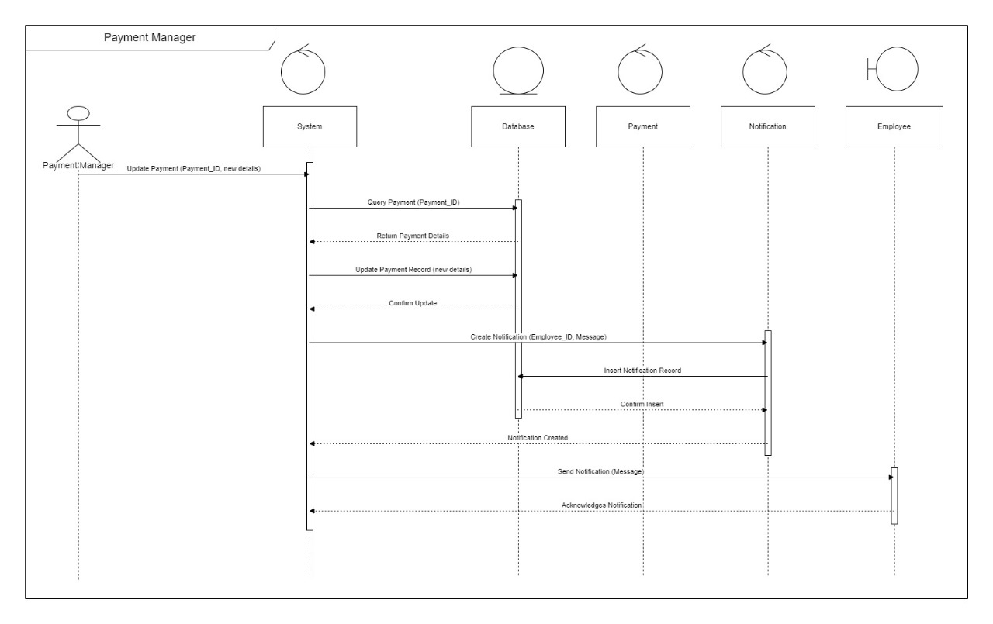

### Activity Diagram

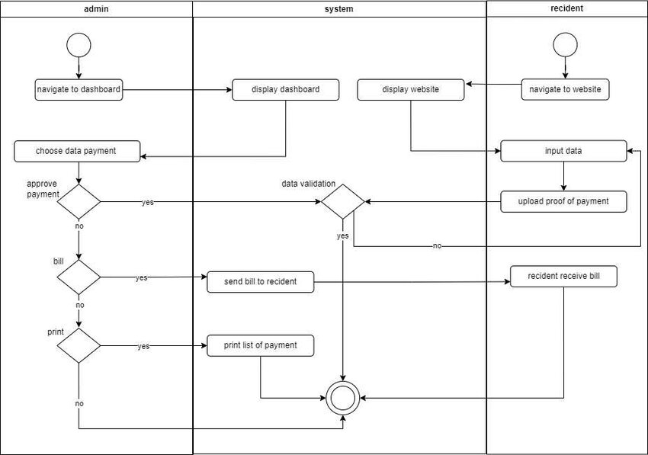

### ER Diagram

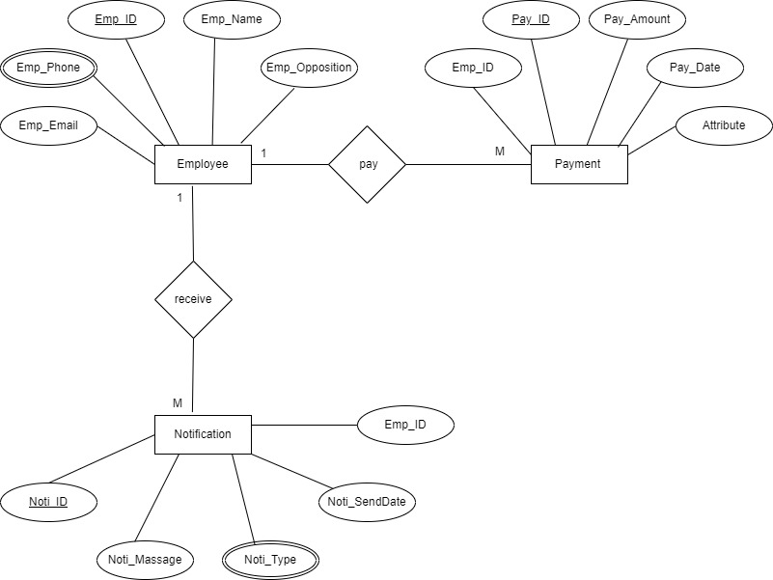

## IT22127082 – Medawatte W. W. M. T. N. B | Operation Management

### Class Diagram

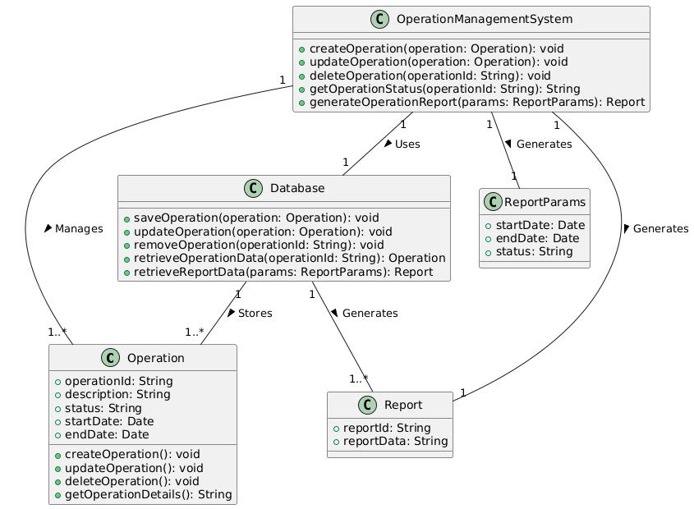

### Sequence Diagram

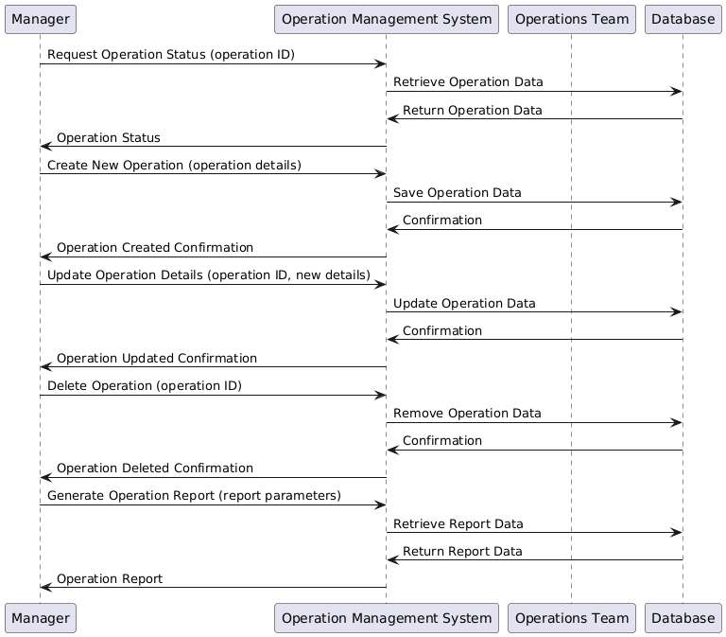

### Activity Diagram

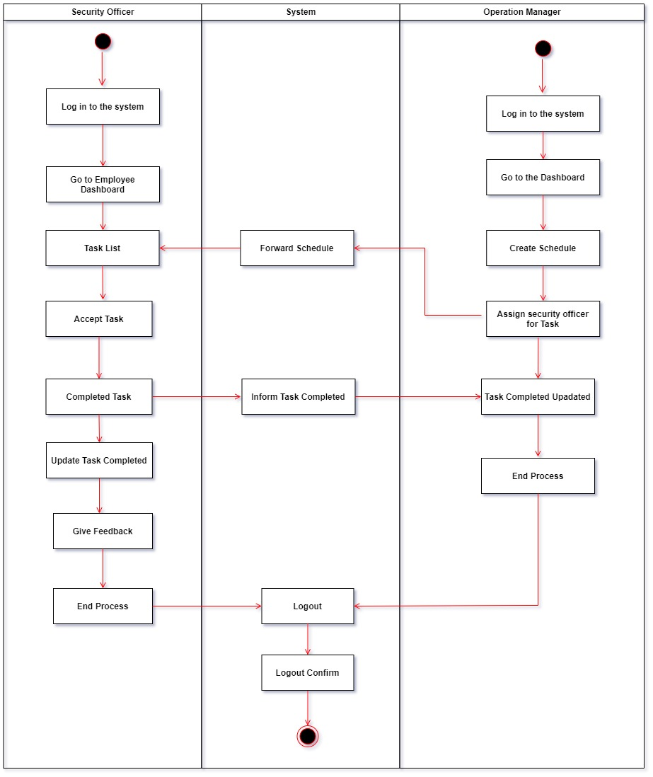

### ER Diagram

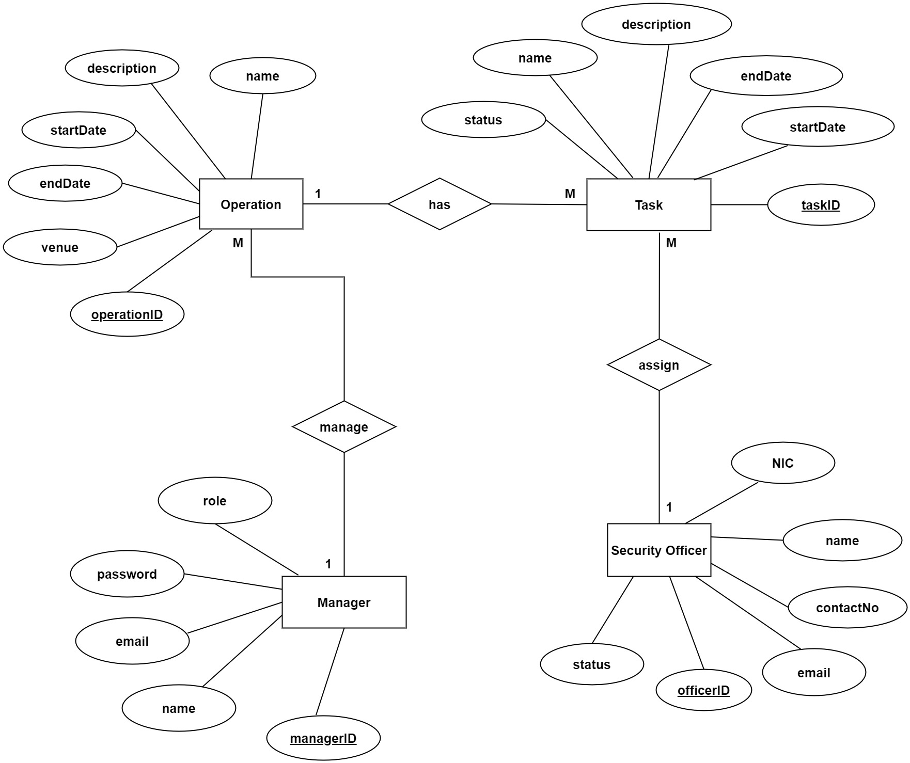

## IT22132628 – Kusumsiri P. A. S. S | Inventory Management

### Class Diagram

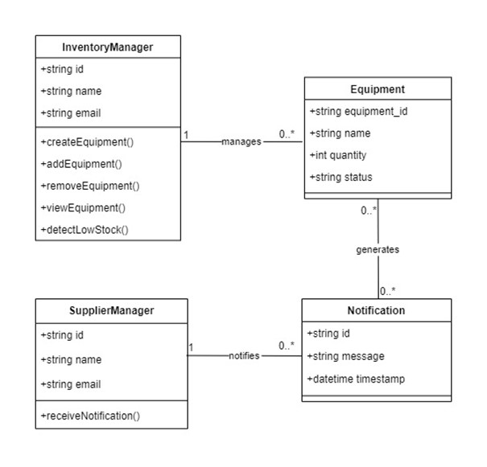

### Sequence Diagram

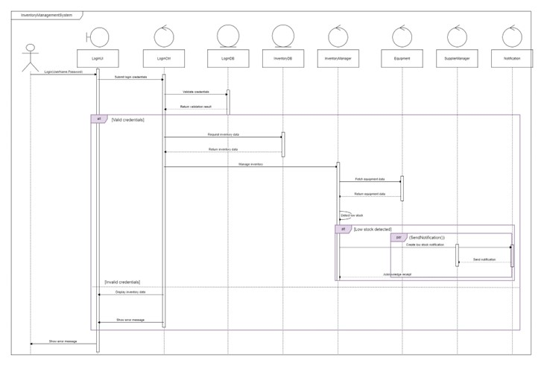

### Activity Diagram

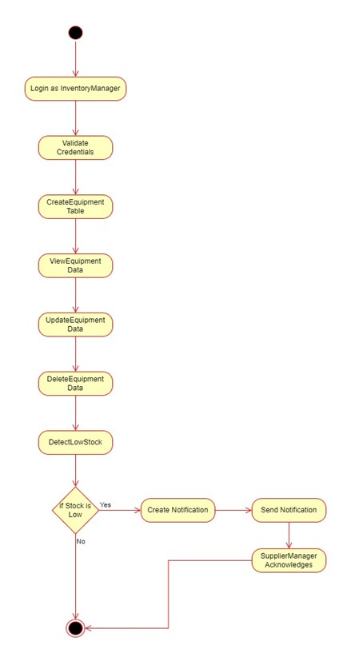

### ER Diagram

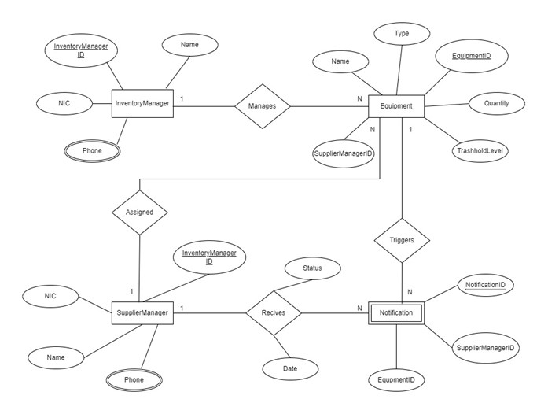

## IT22197146 – Ranasinghe R. A. R. V. C | Leave Management

### Class Diagram

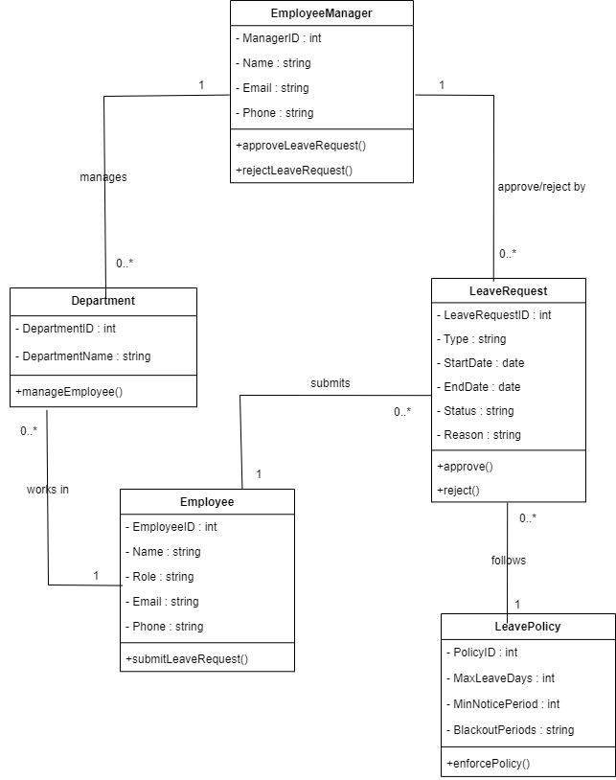

### Sequence Diagram

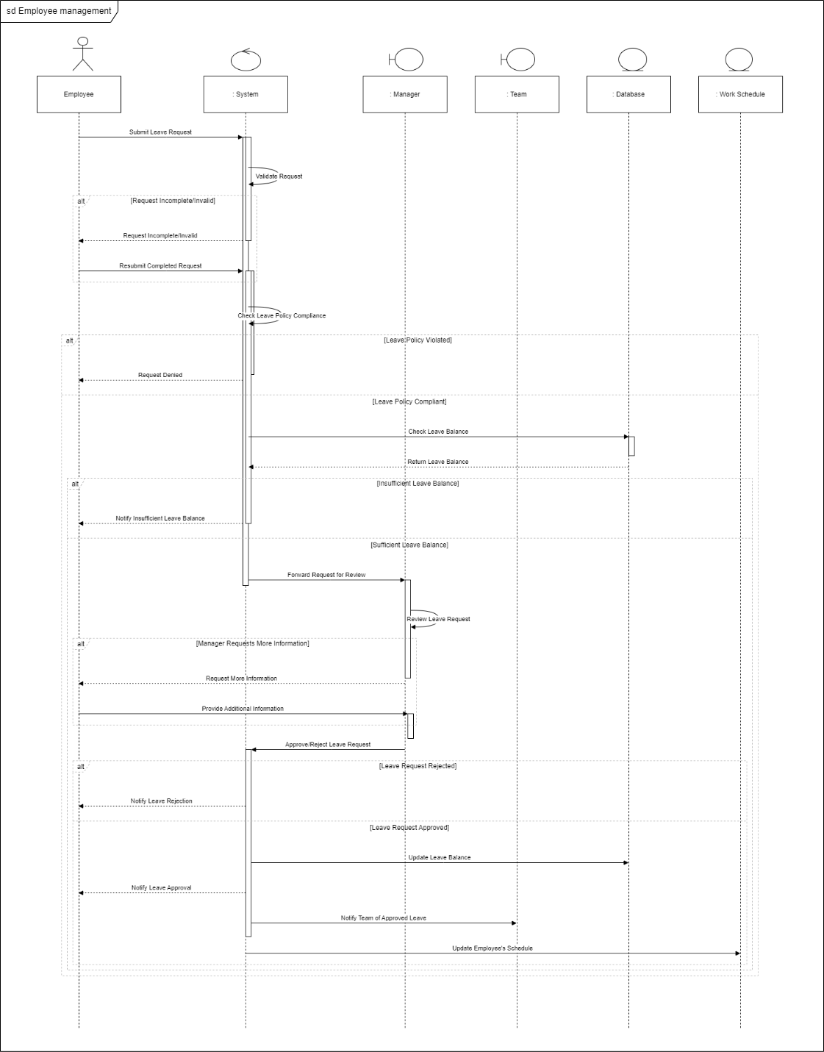

### Activity Diagram

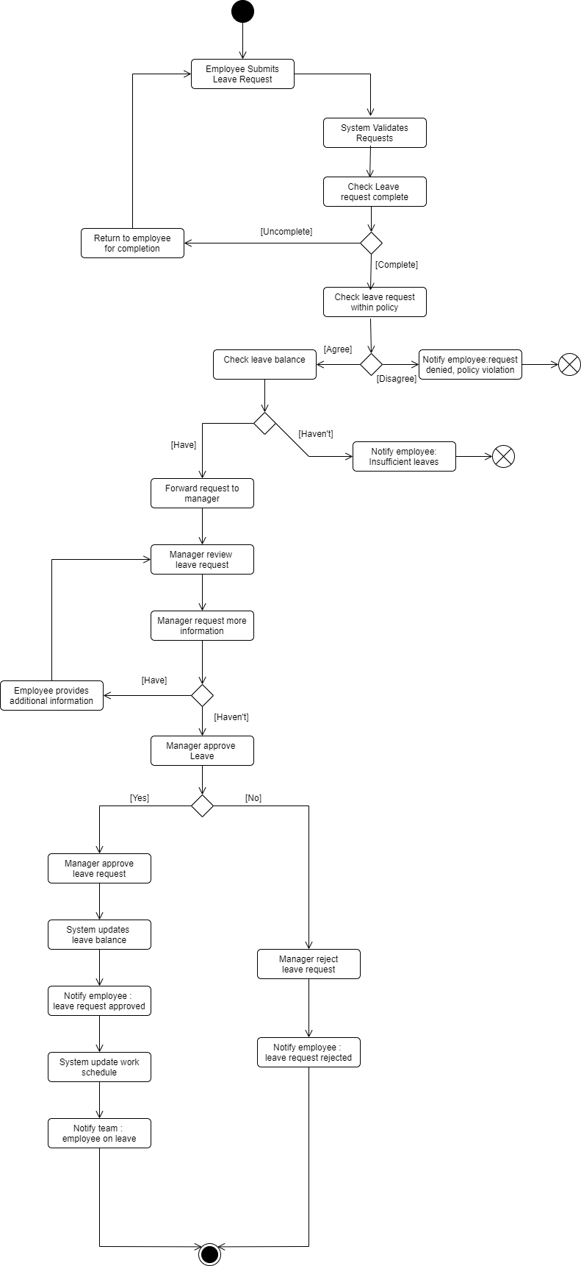

### ER Diagram

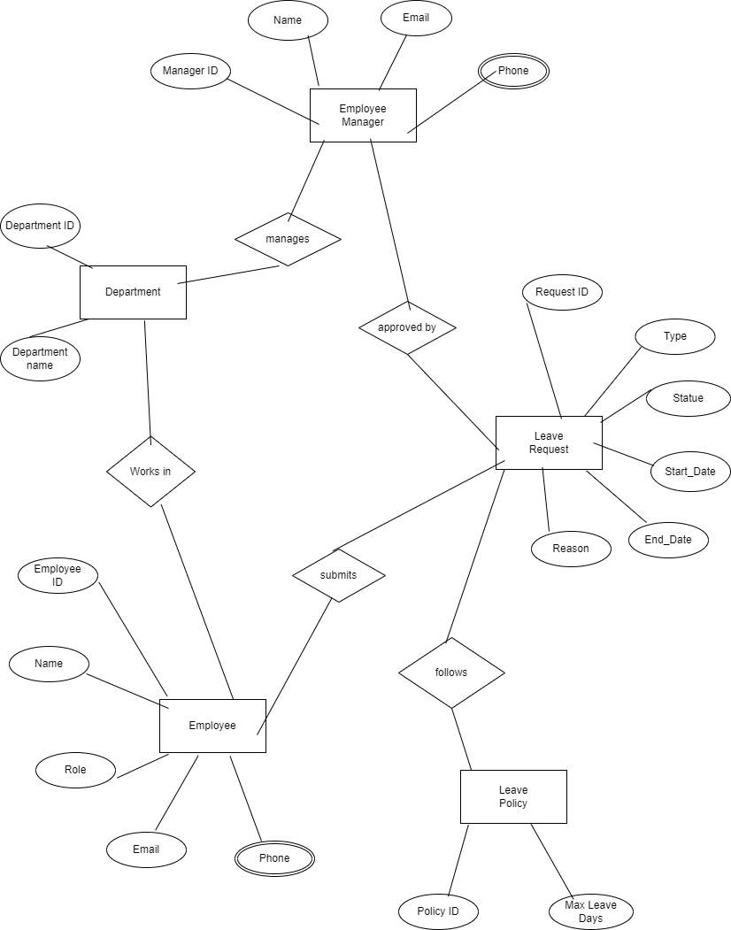

# System Diagram

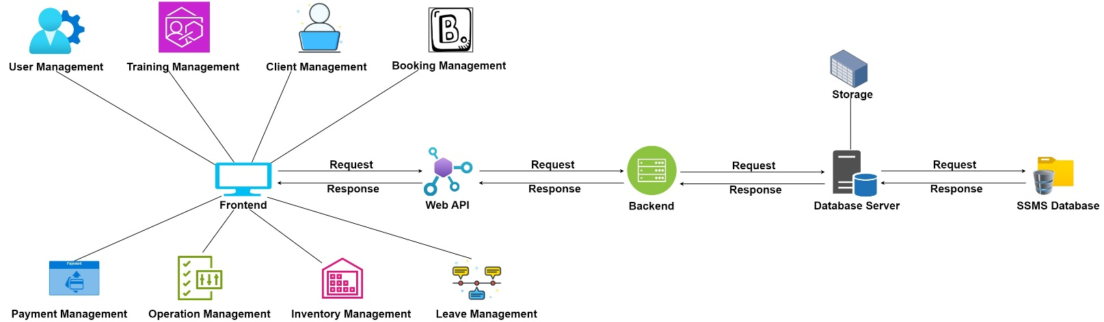

# Relational Schema

## IT22325228 – Fernando K. K. C | User Management

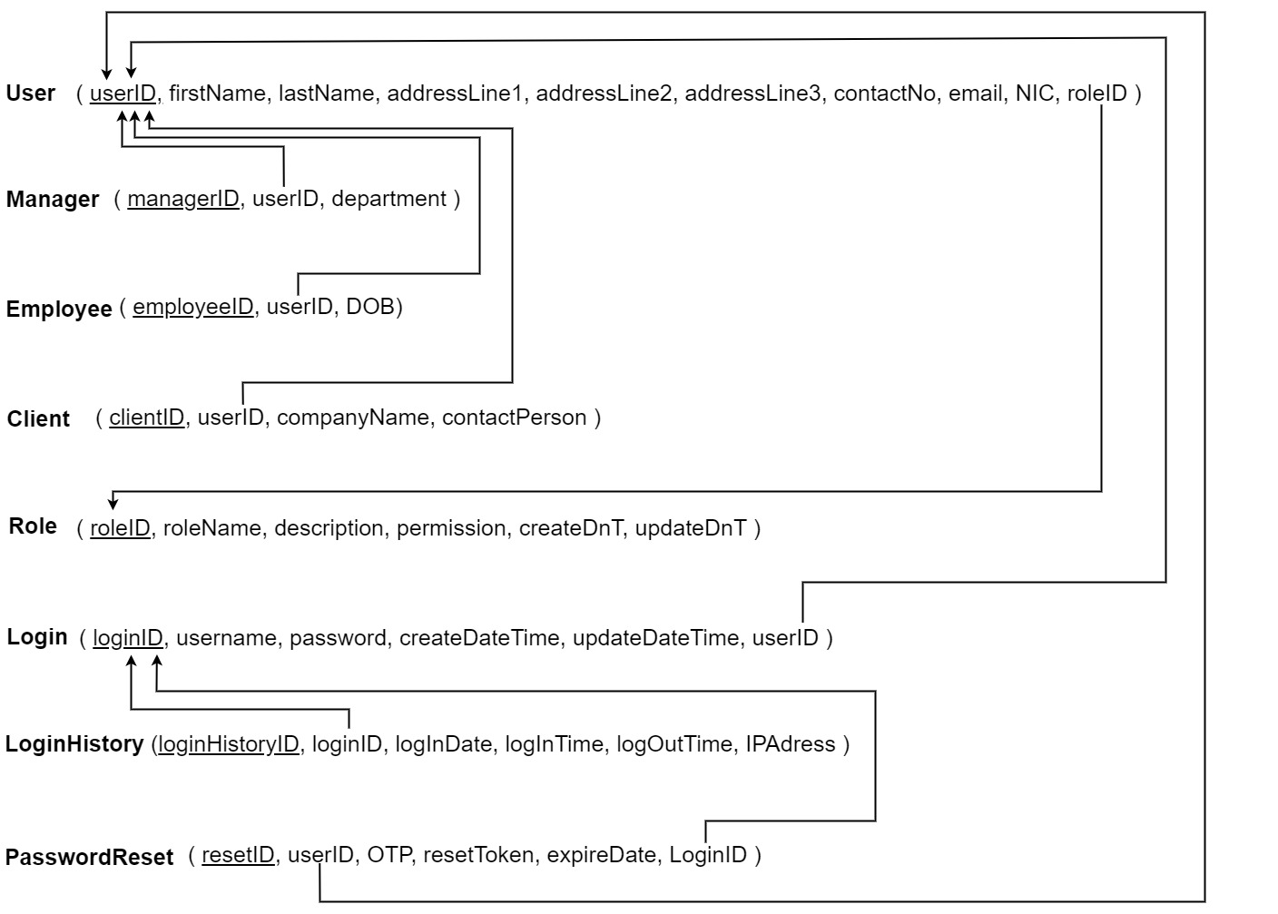

## IT22907998 – Sadisha R. M. M | Training Management

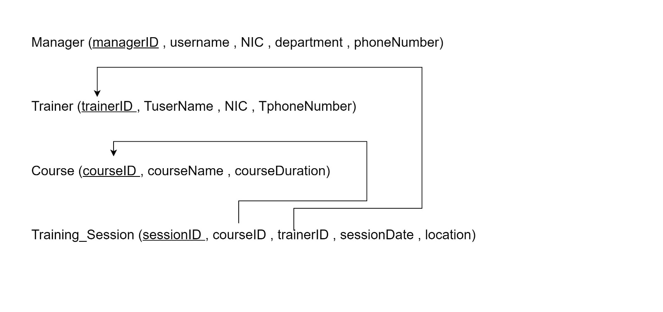IT20145552 – Dissanayaka D. M. S. M | Client Management

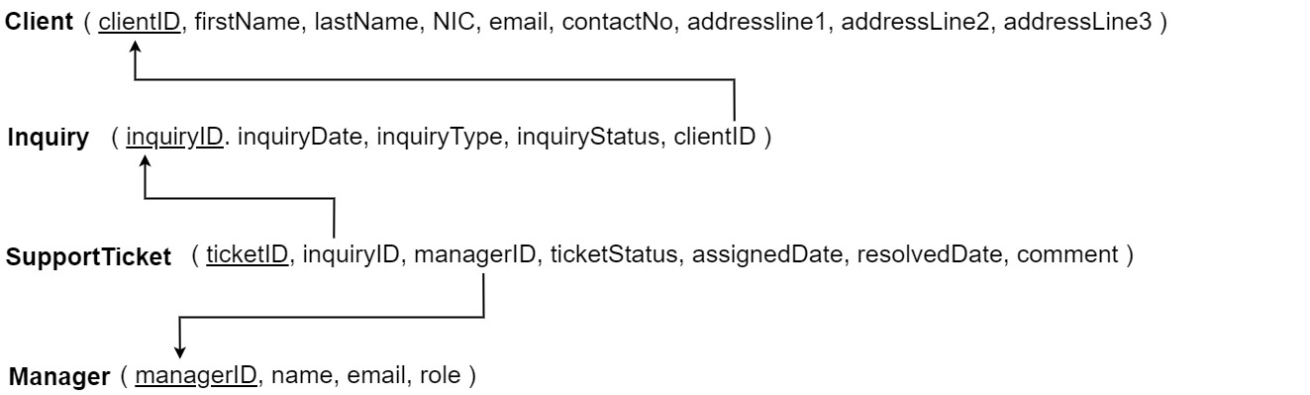

## IT22257086 – Randiw. E. Y | Booking Management

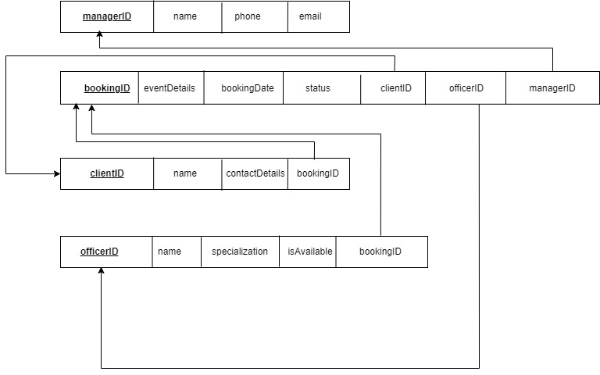

## 

## IT22293480 – Jayodhya J. D. H | Payment Management

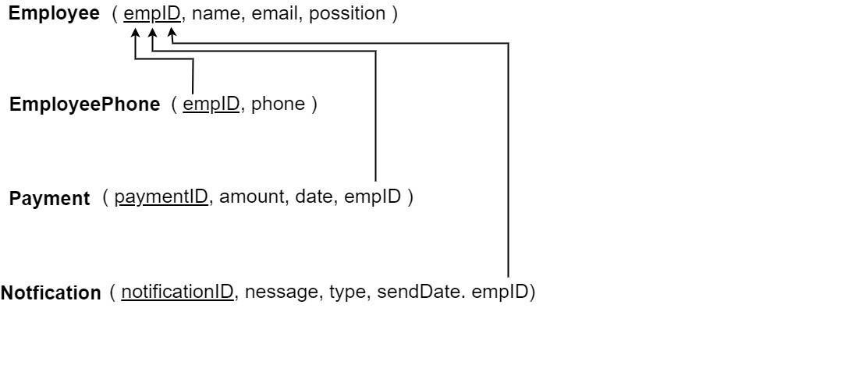

## IT22127082 – Medawatte W. W. M. T. N. B | Operation Management

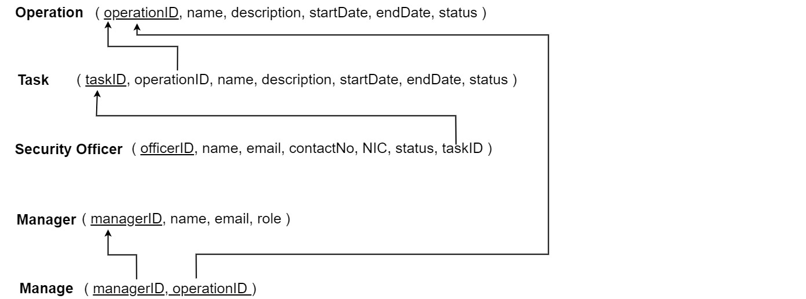

## 

## IT22132628 – Kusumsiri P. A. S. S | Inventory Management

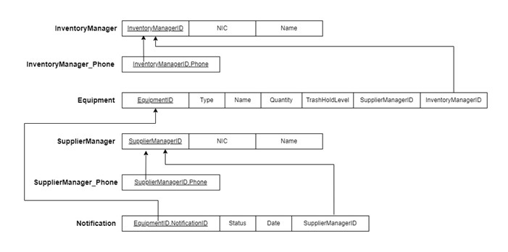

## IT22197146 – Ranasinghe R. A. R. V. C | Leave Management

